Organic Open Curves
# Source: AI Source: Provided by: [Data Path: Persons Table -> ID Column: 1, Name_En Column: Motasem Essam] -> From: [ChatGPT] on [7/25/2026]
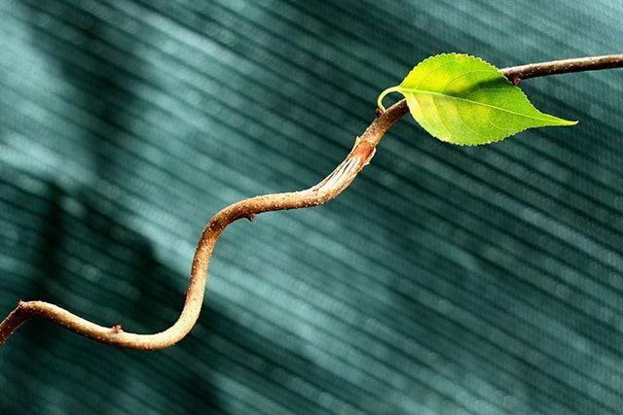
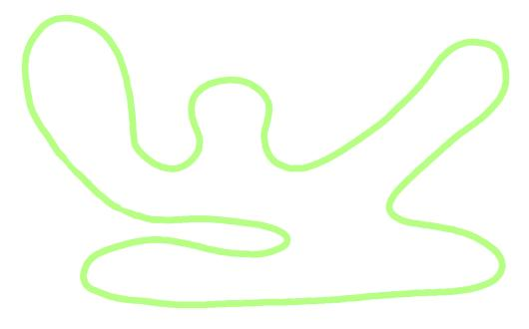
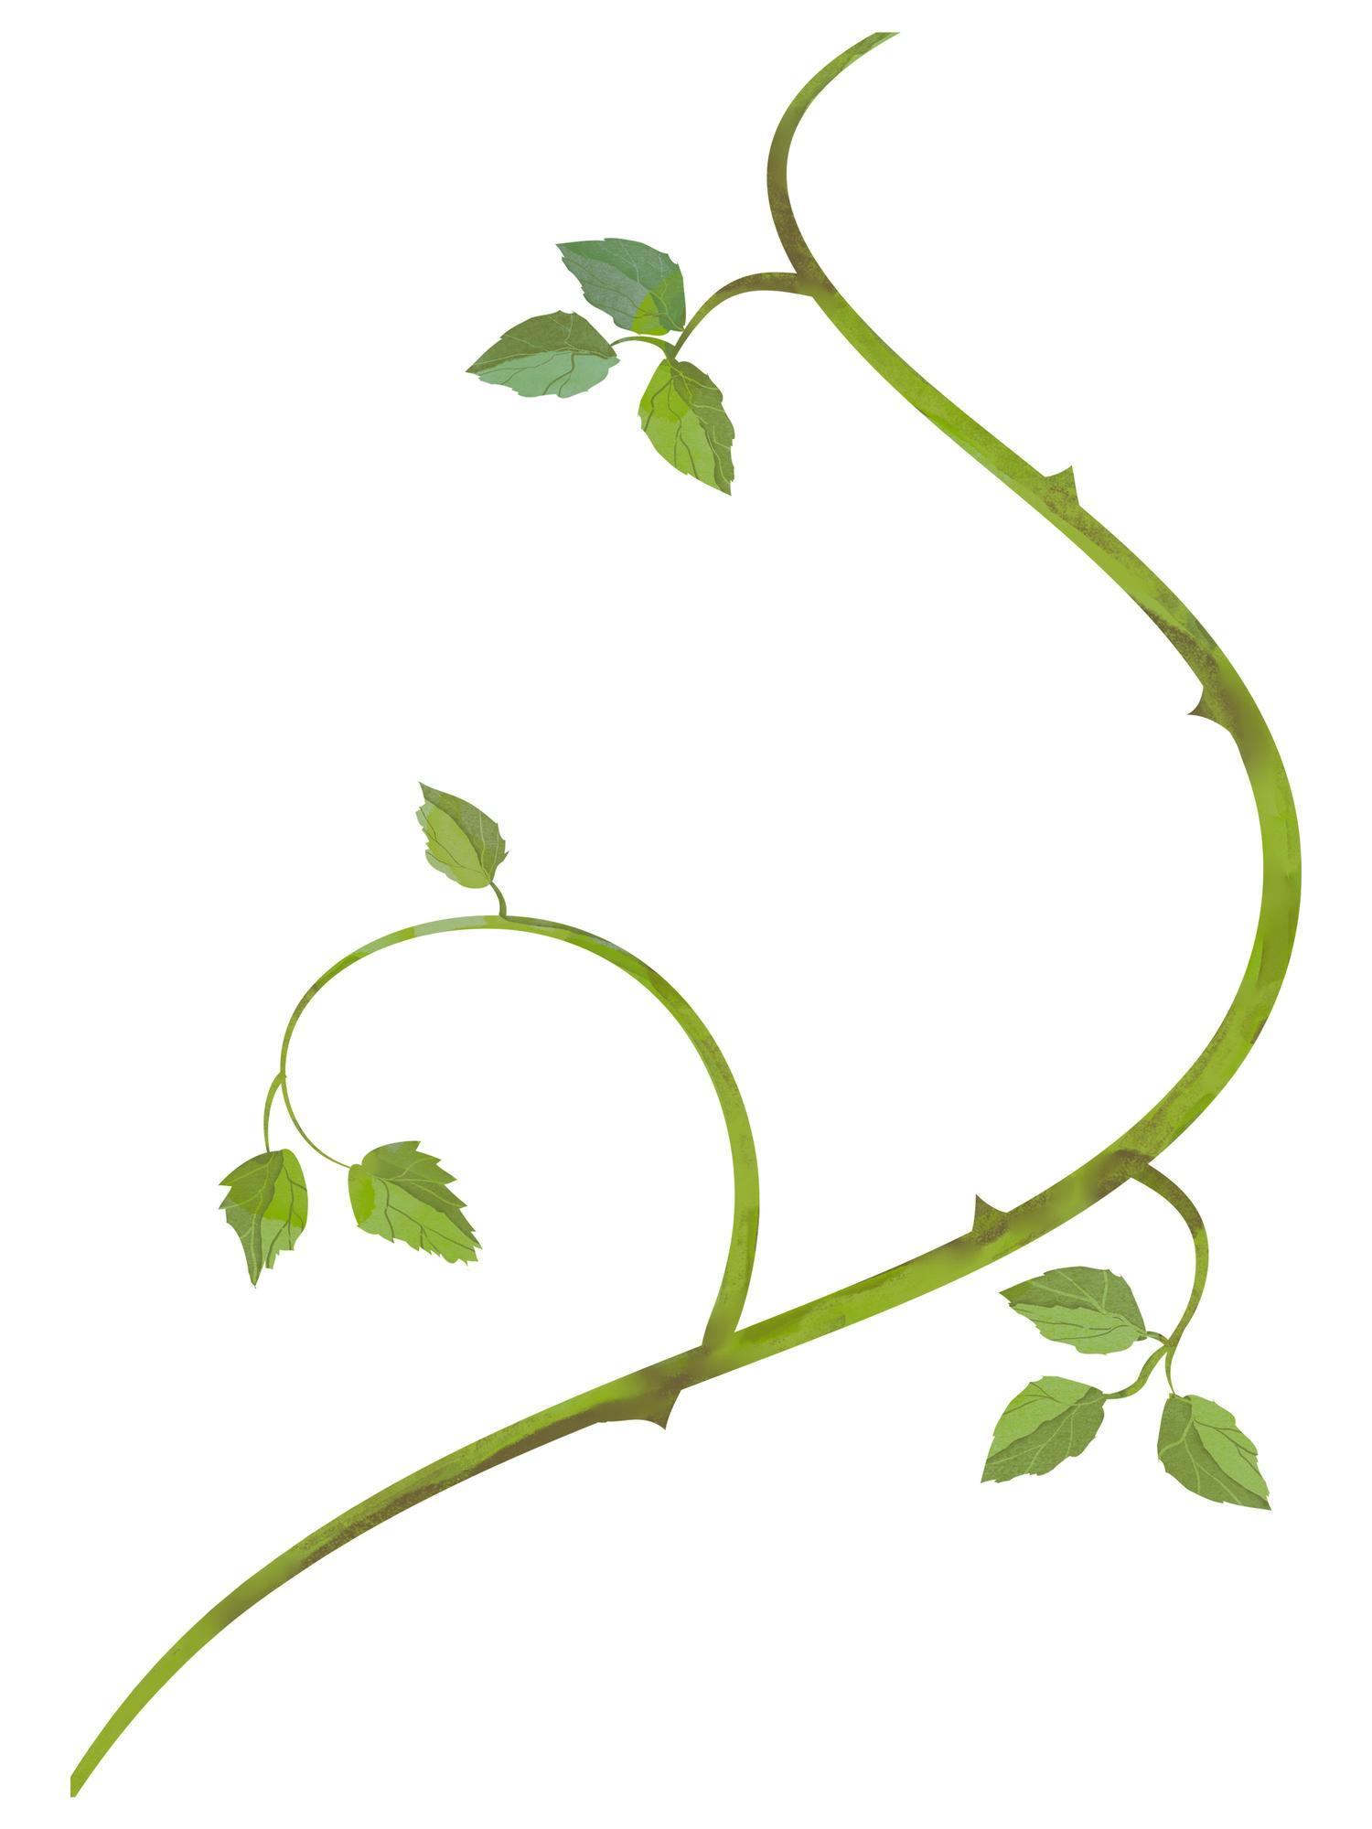
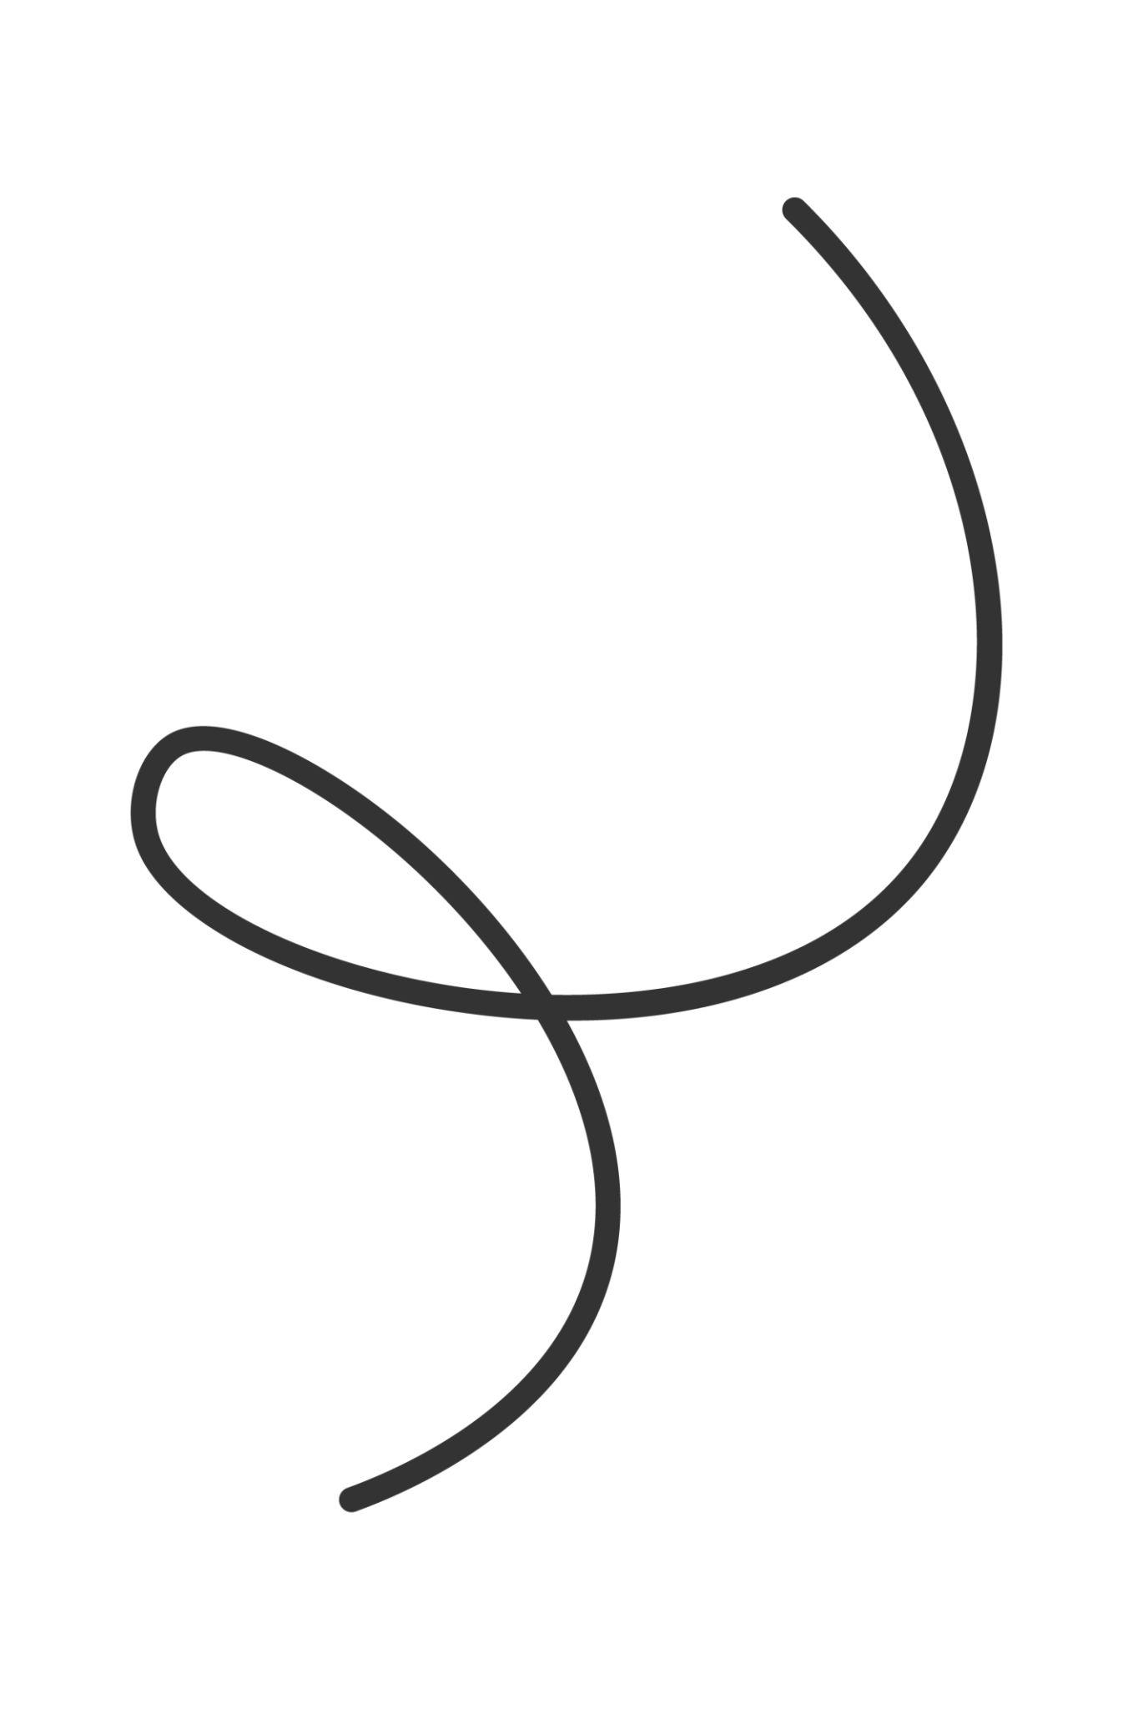
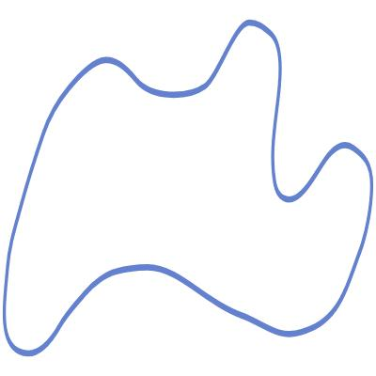

Definition
# Source: AI Source: Provided by: [Data Path: Persons Table -> ID Column: 1, Name_En Column: Motasem Essam] -> From: [ChatGPT] on [7/25/2026]
An Organic Open Curve is an open, irregular curved shape with a natural, flowing, or living appearance. It does not form a closed boundary and usually does not follow a simple geometric equation.
$$\boxed{\text{Organic Open Curve}=\text{Open}+\text{Curved}+\text{Irregular}+\text{Natural-Looking}}$$
Examples include portions of branches, vines, roots, coastlines, flowing plant stems, and other natural-looking curved forms.

Characteristics
# Source: AI Source: Provided by: [Data Path: Persons Table -> ID Column: 1, Name_En Column: Motasem Essam] -> From: [ChatGPT] on [7/25/2026]
An Organic Open Curve:
- Is open.
- Has two distinct endpoints.
- Is primarily curved.
- Usually has irregular curvature.
- Does not normally follow a simple mathematical pattern.
- Does not enclose an area by itself.
- Has a natural or living appearance.
- May contain smooth changes in direction.
- May be asymmetric.
- Can have varying width or curvature when represented as a real-world boundary.

Types of Organic Open Curves

1. Natural Organic Open Curve
# Source: AI Source: Provided by: [Data Path: Persons Table -> ID Column: 1, Name_En Column: Motasem Essam] -> From: [ChatGPT] on [7/25/2026]
A curved path that occurs naturally in an object, organism, or landscape.
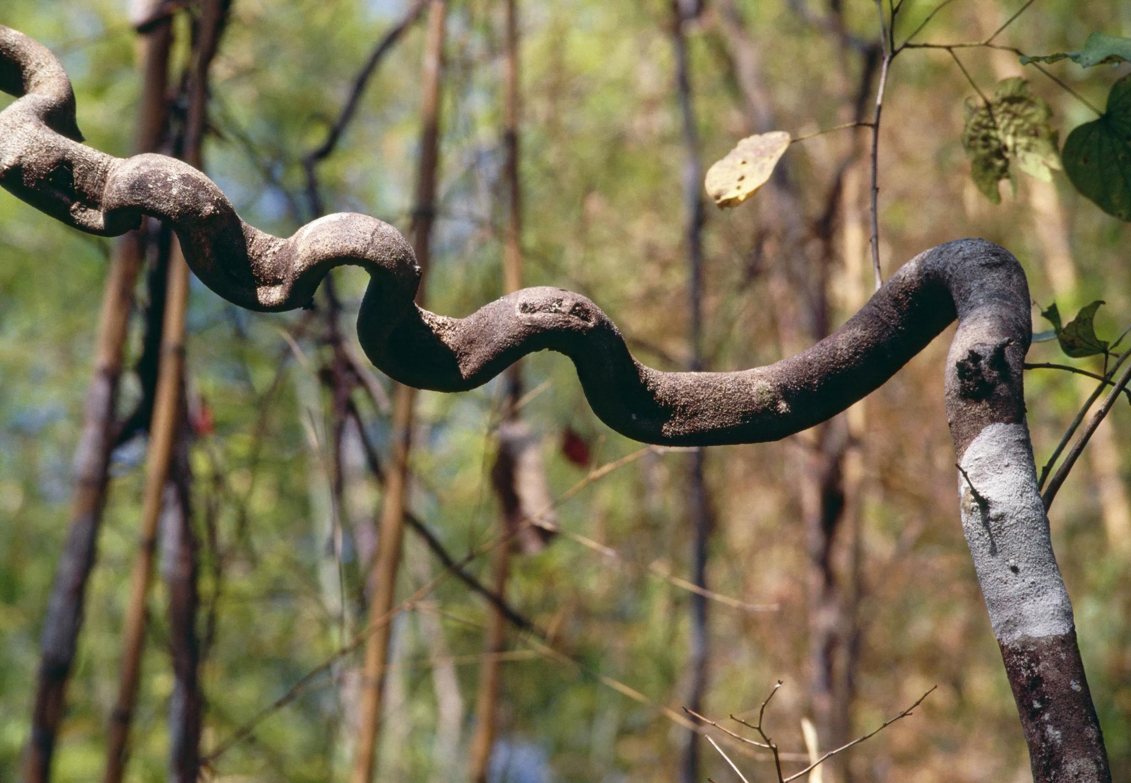
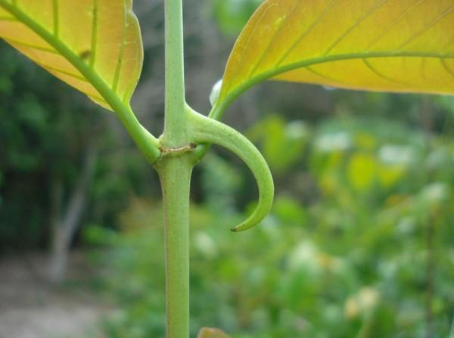
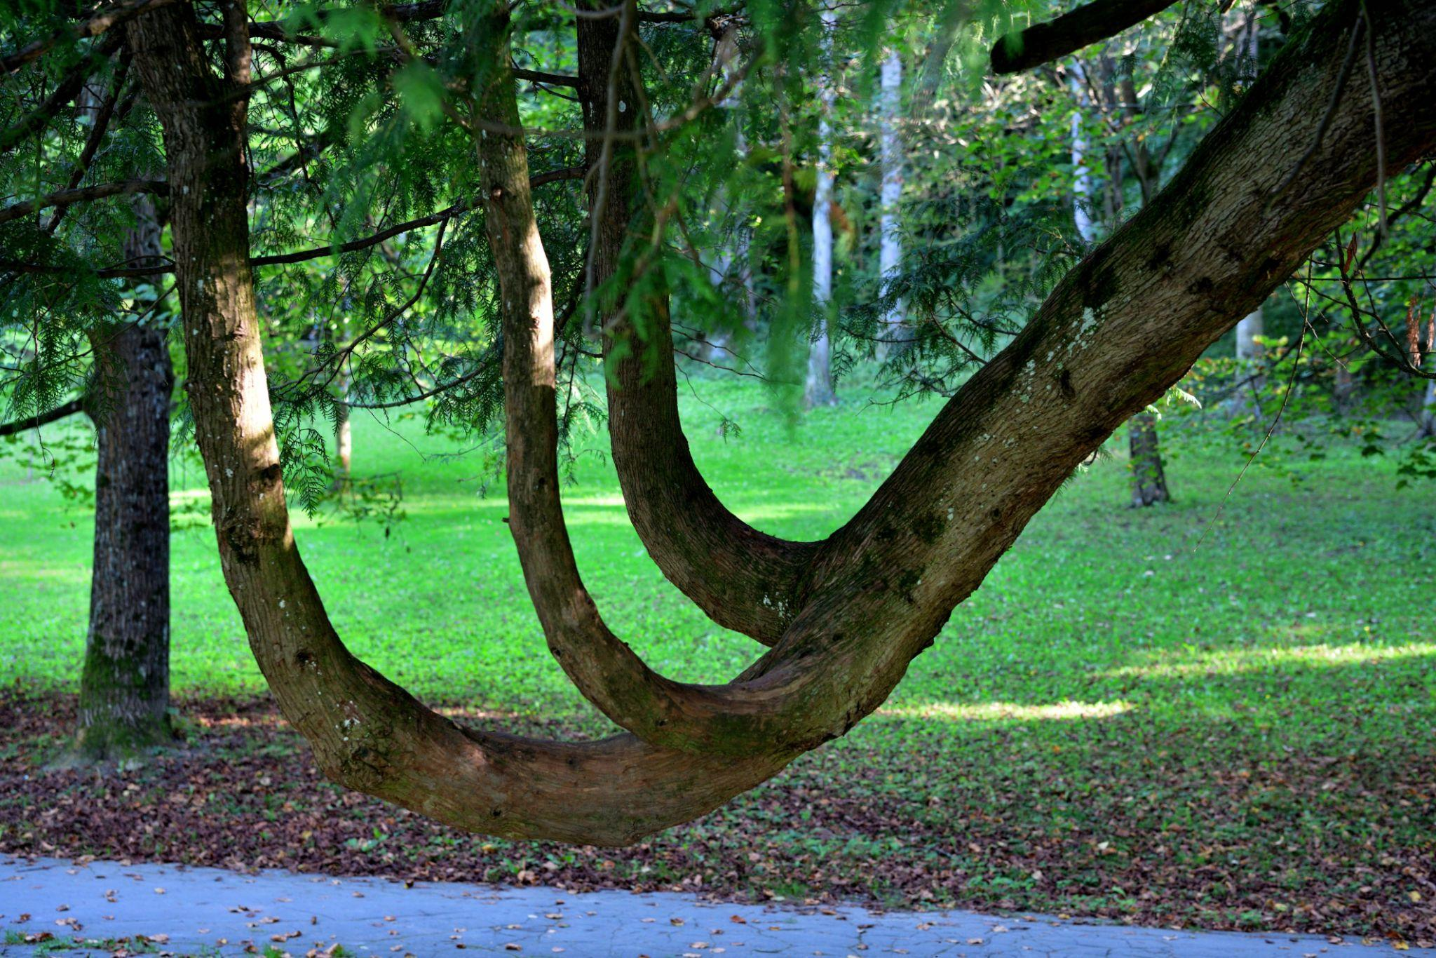
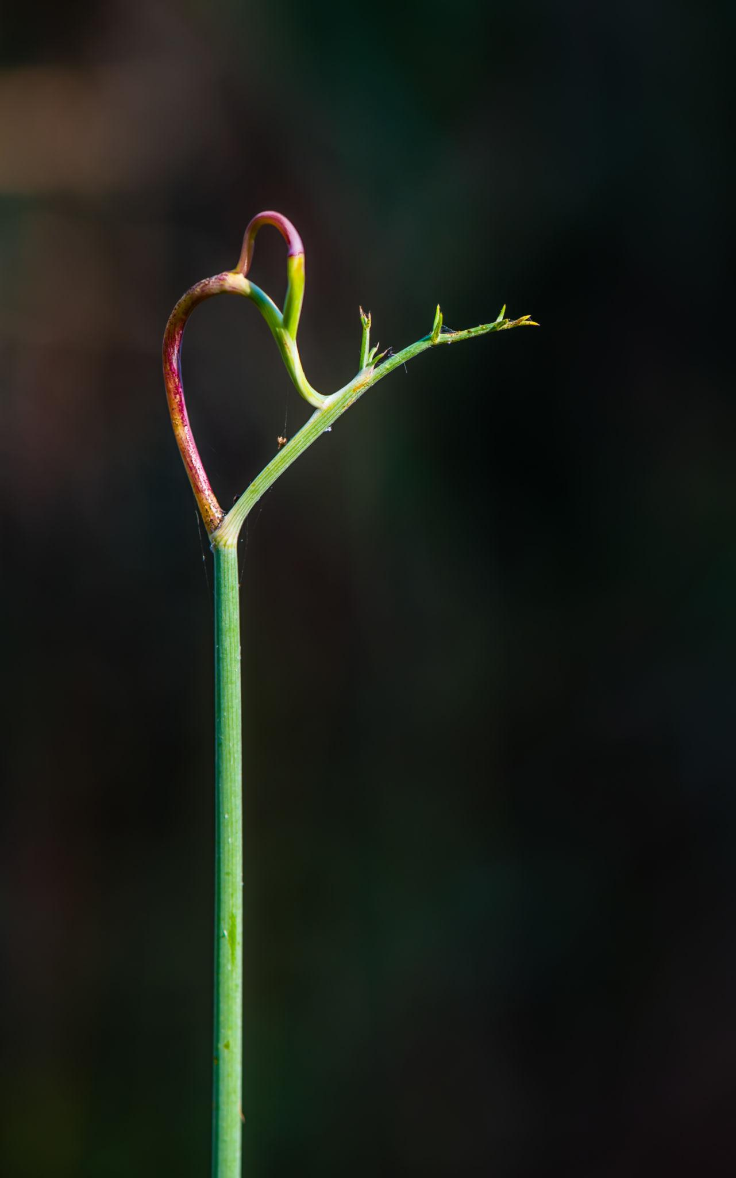
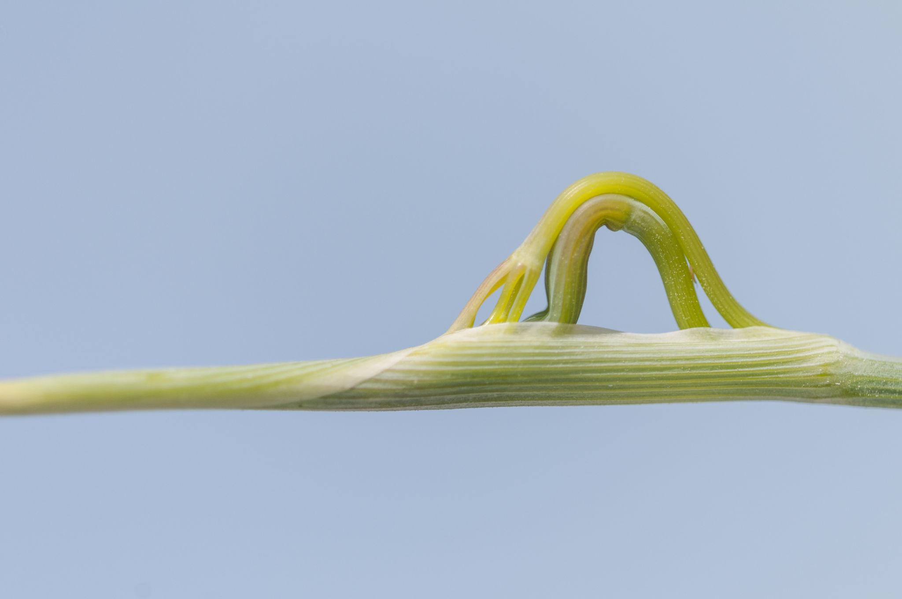
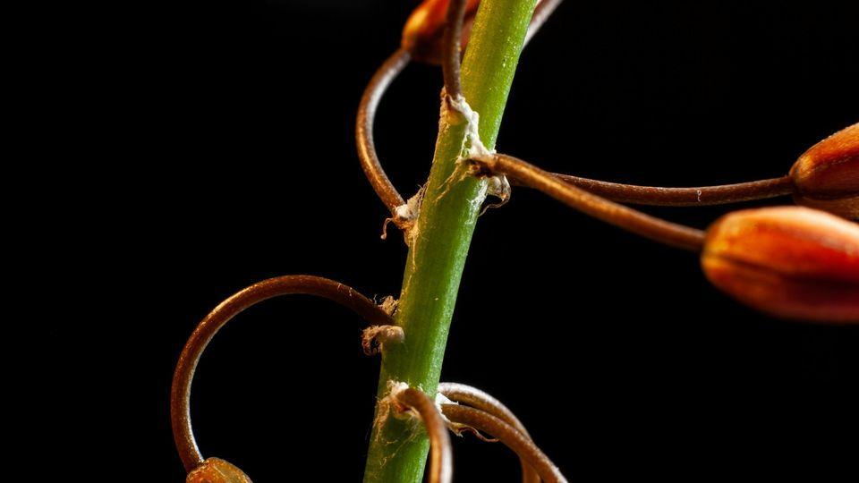
Examples: branches, roots, plant stems, and natural edges.

2. Branch-Like Organic Open Curve
# Source: AI Source: Provided by: [Data Path: Persons Table -> ID Column: 1, Name_En Column: Motasem Essam] -> From: [ChatGPT] on [7/25/2026]
A curve resembling part of a tree branch or branching plant structure.
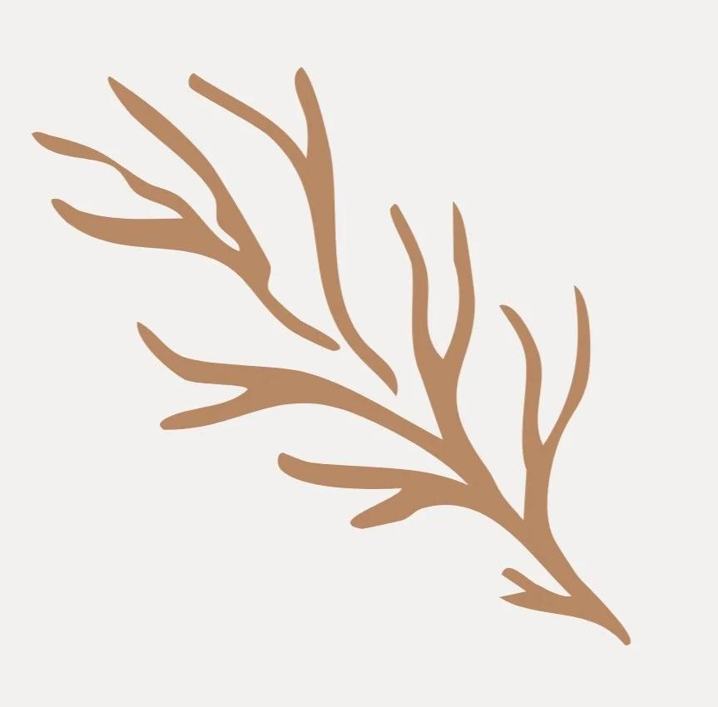
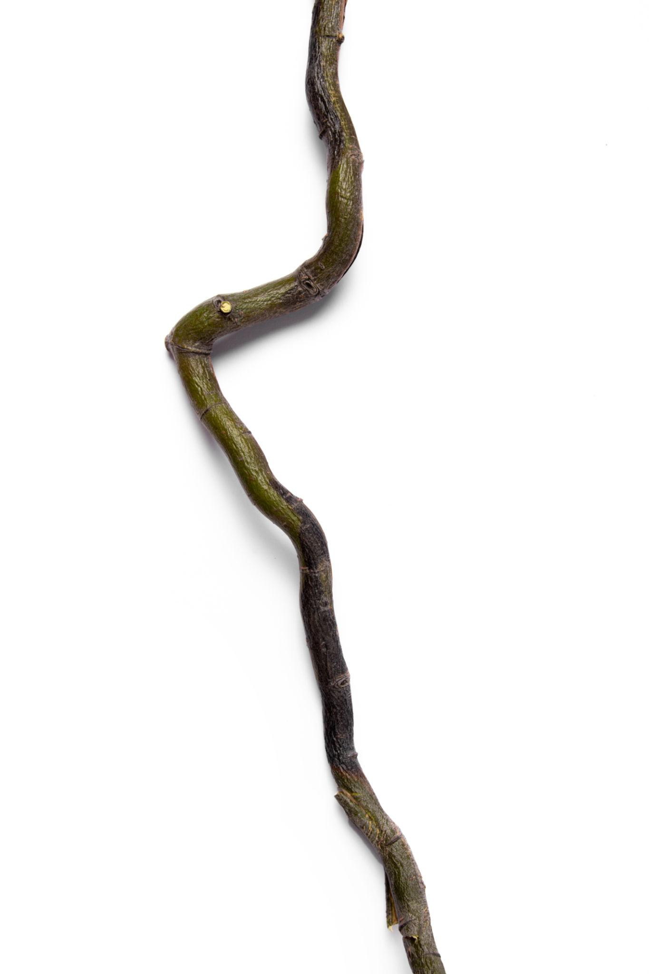
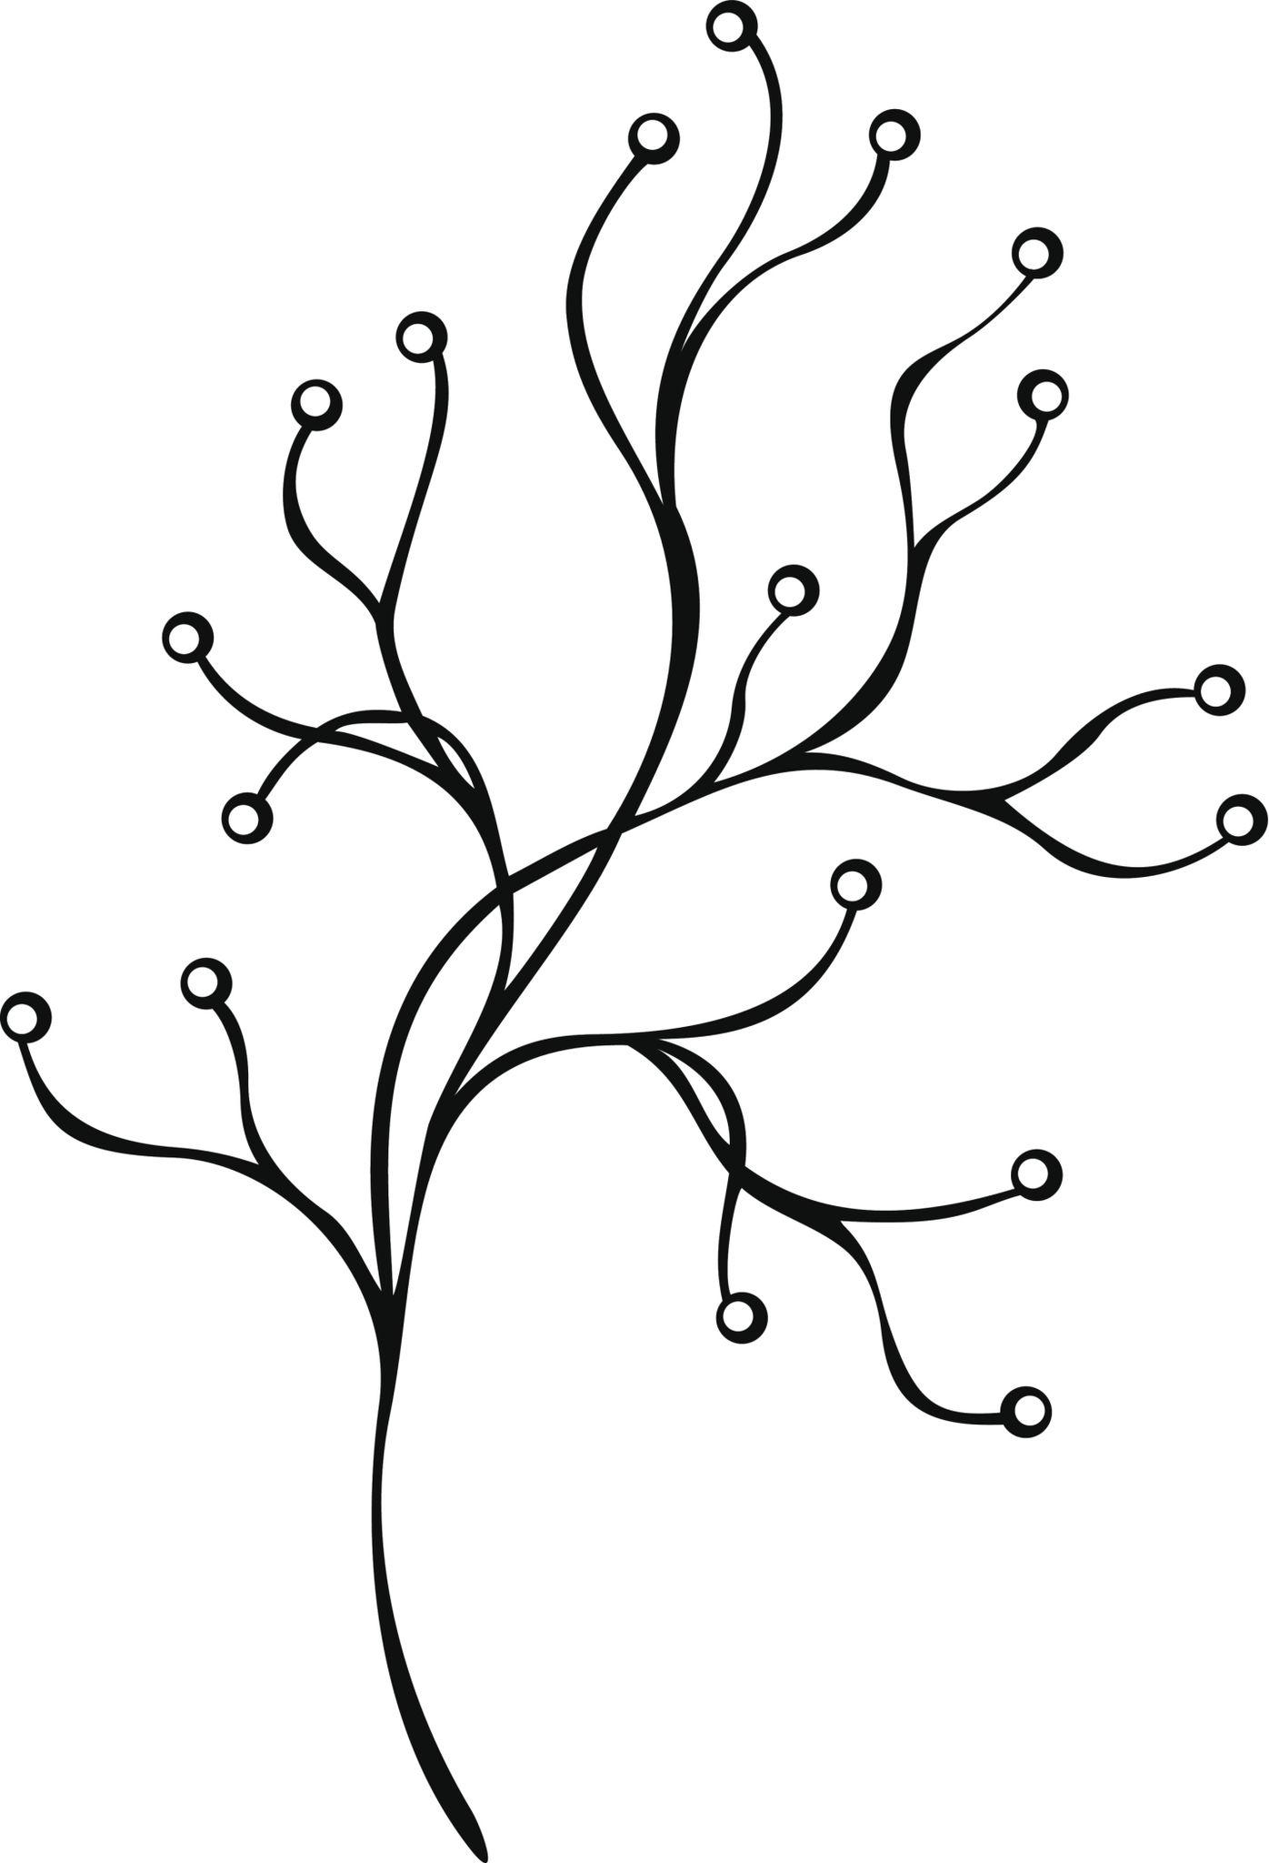
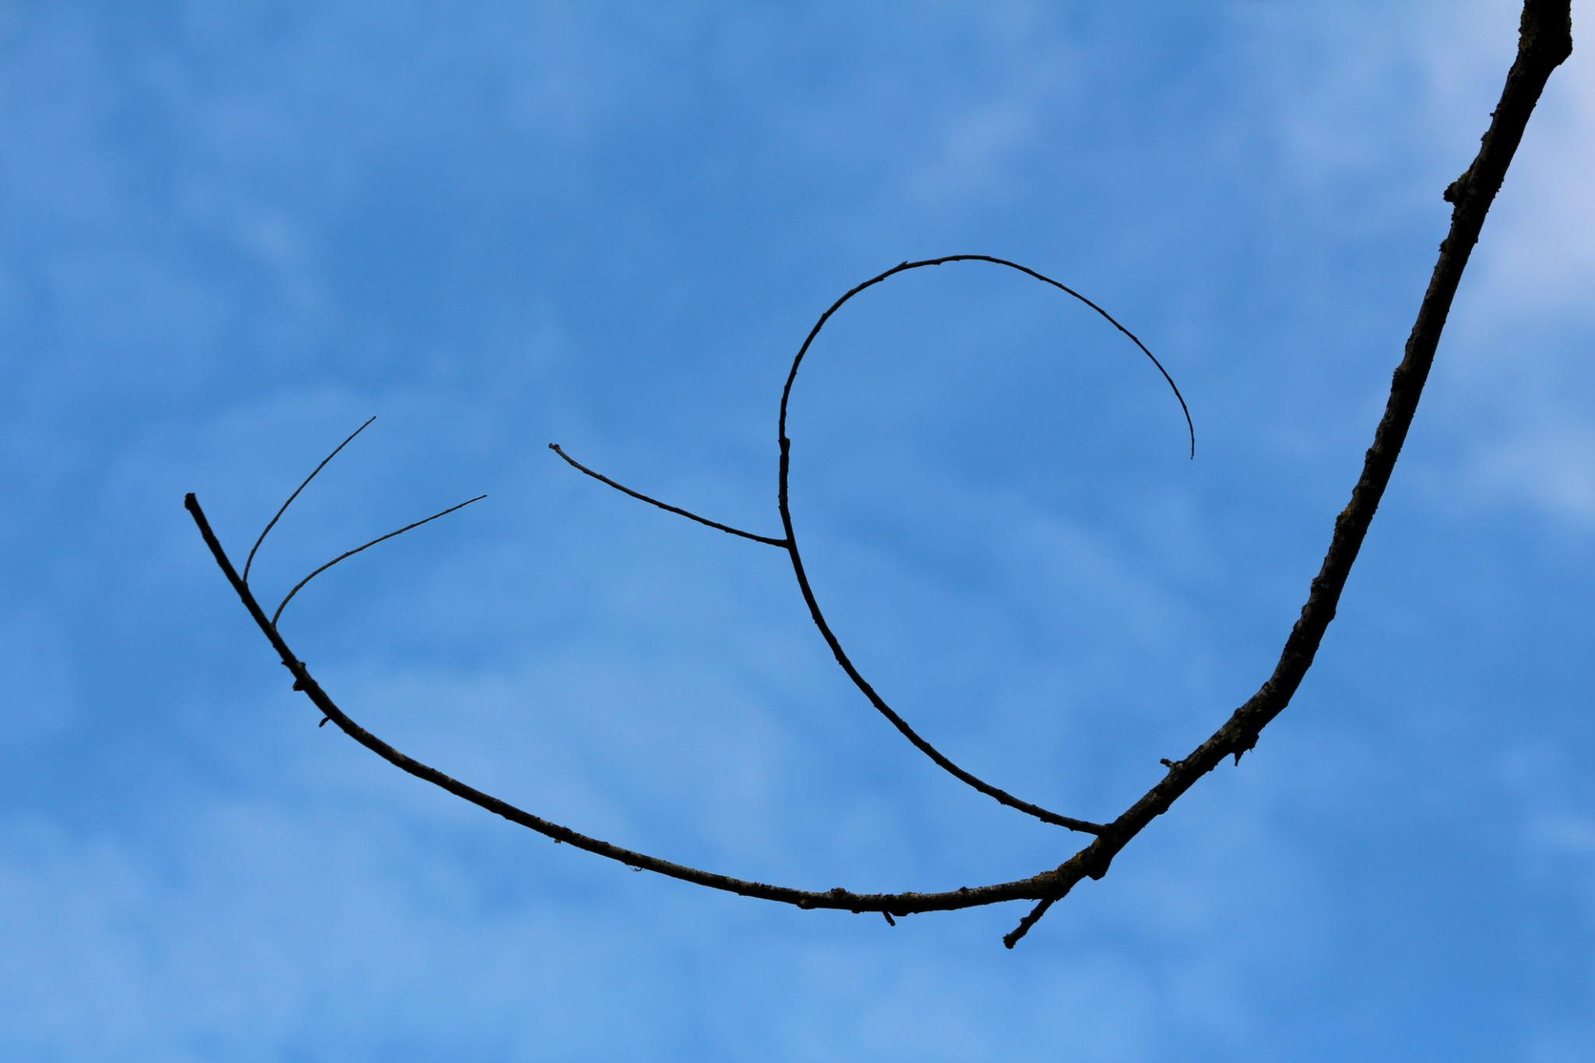
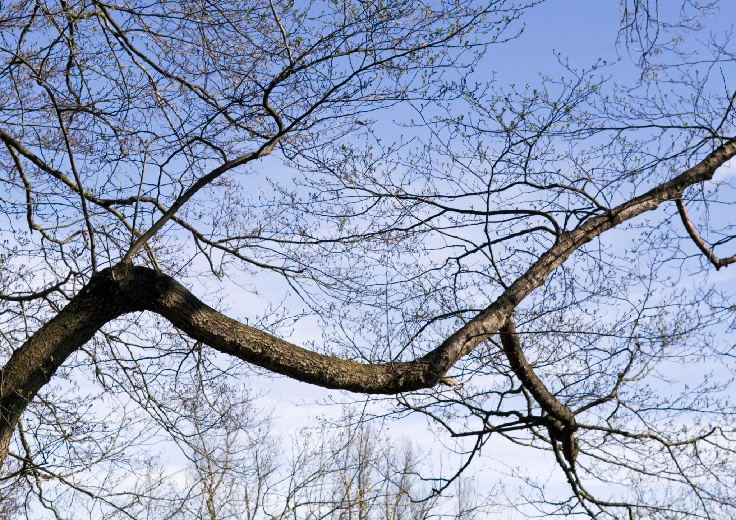
It usually has gradual changes in direction and an irregular natural appearance.

3. Vine-Like Organic Open Curve
# Source: AI Source: Provided by: [Data Path: Persons Table -> ID Column: 1, Name_En Column: Motasem Essam] -> From: [ChatGPT] on [7/25/2026]
A flexible, winding curve resembling a vine or climbing plant.
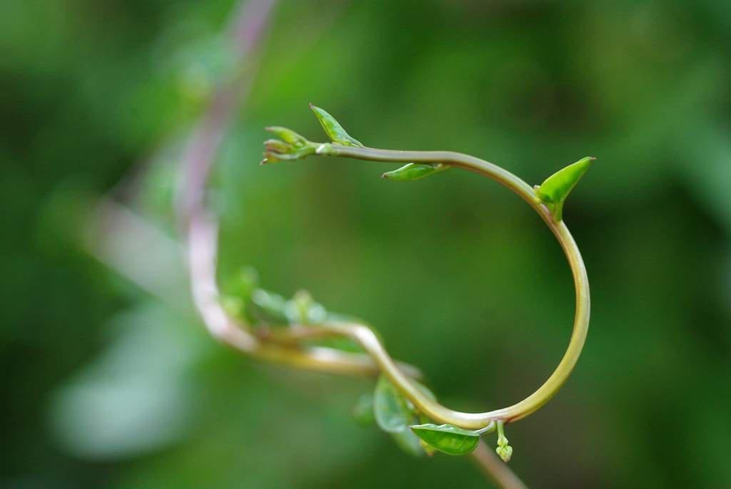
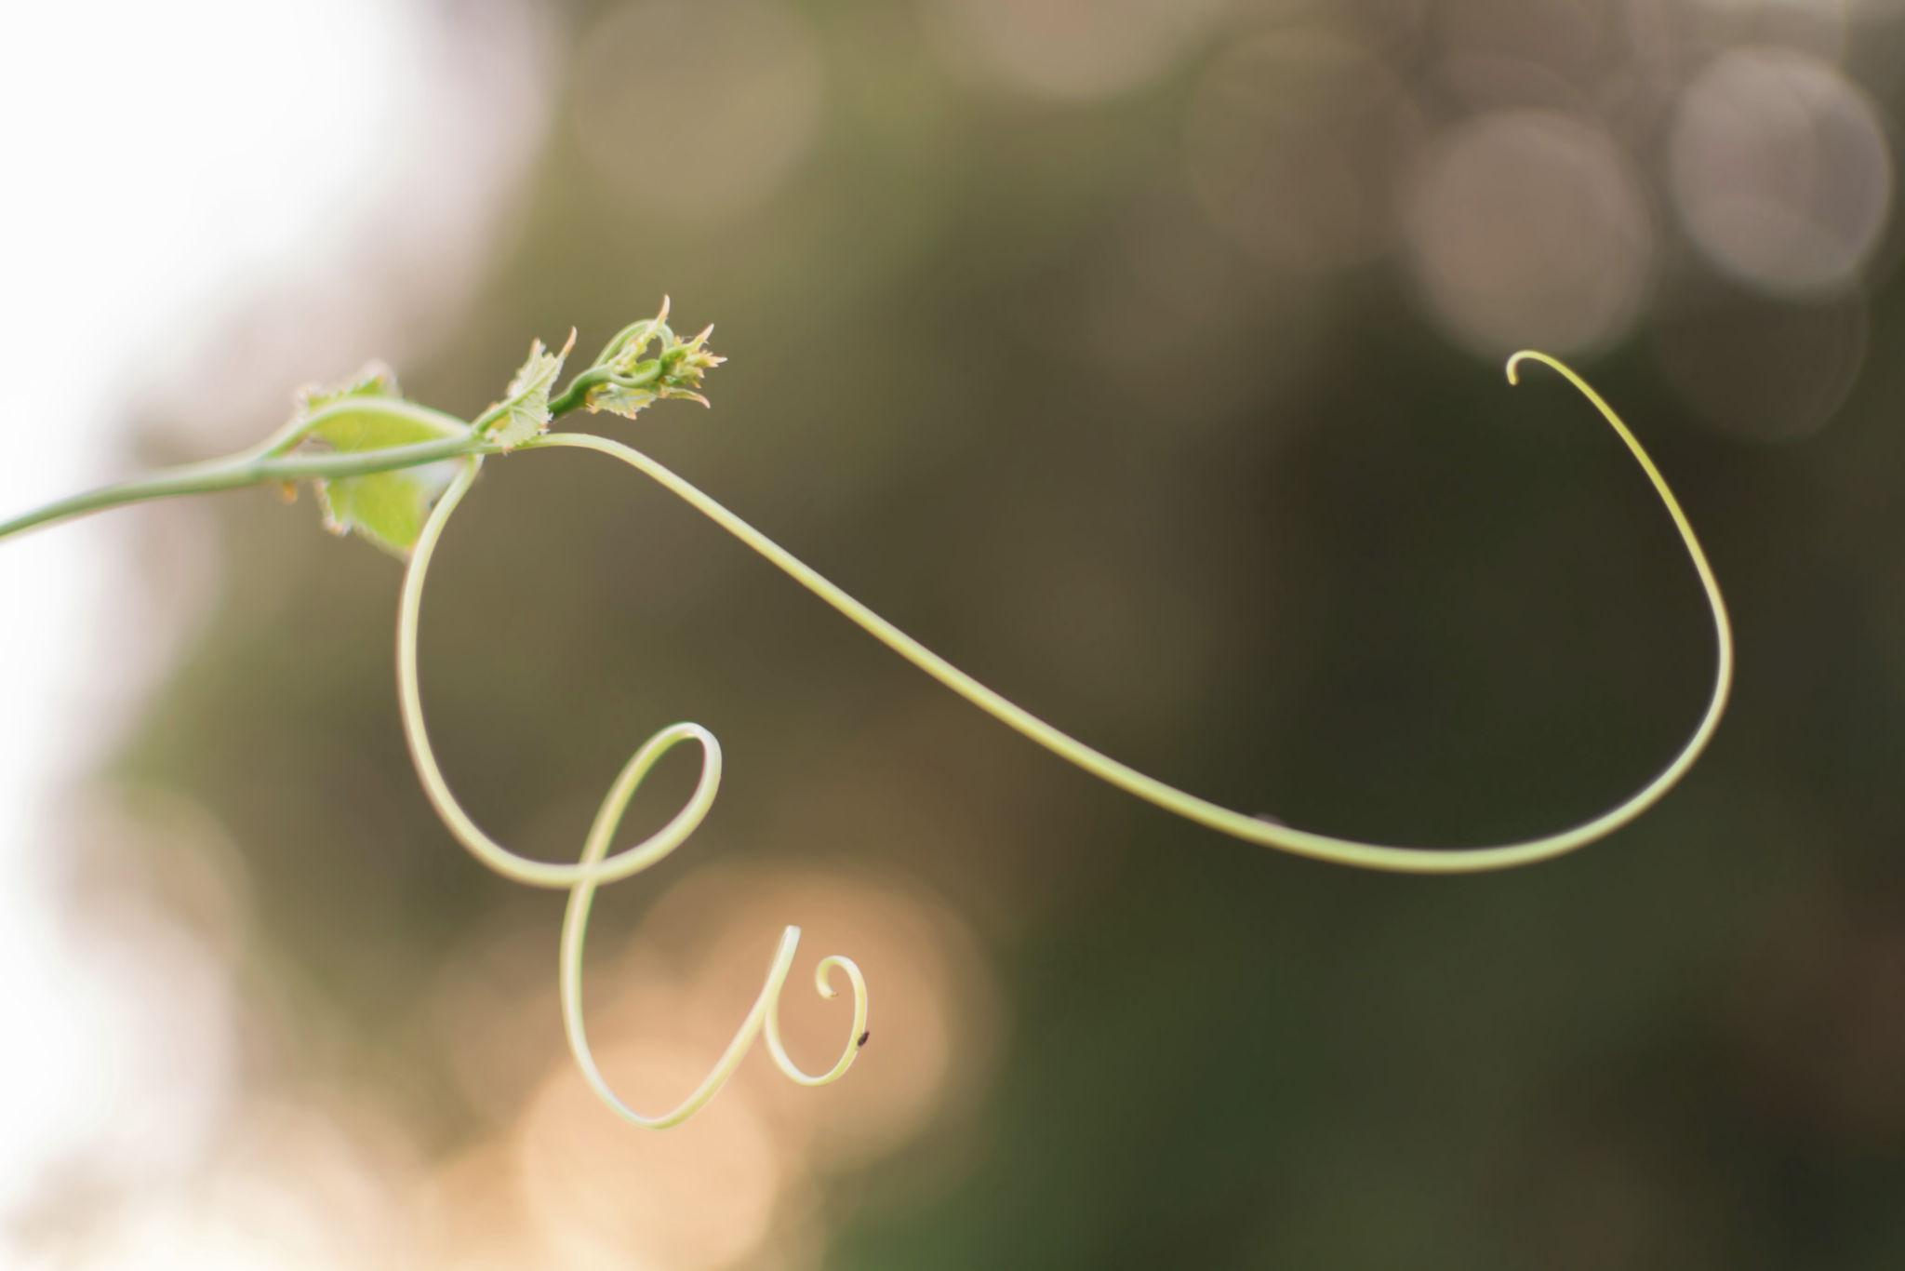
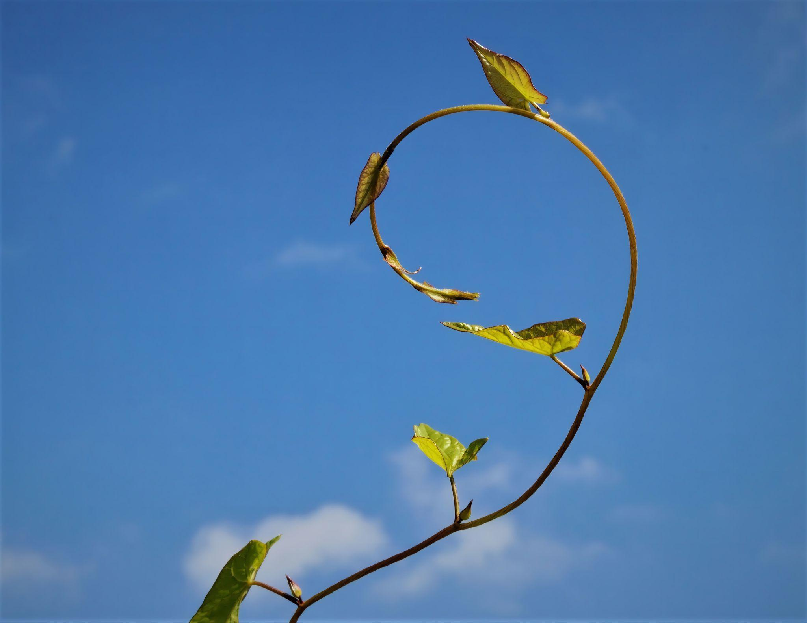
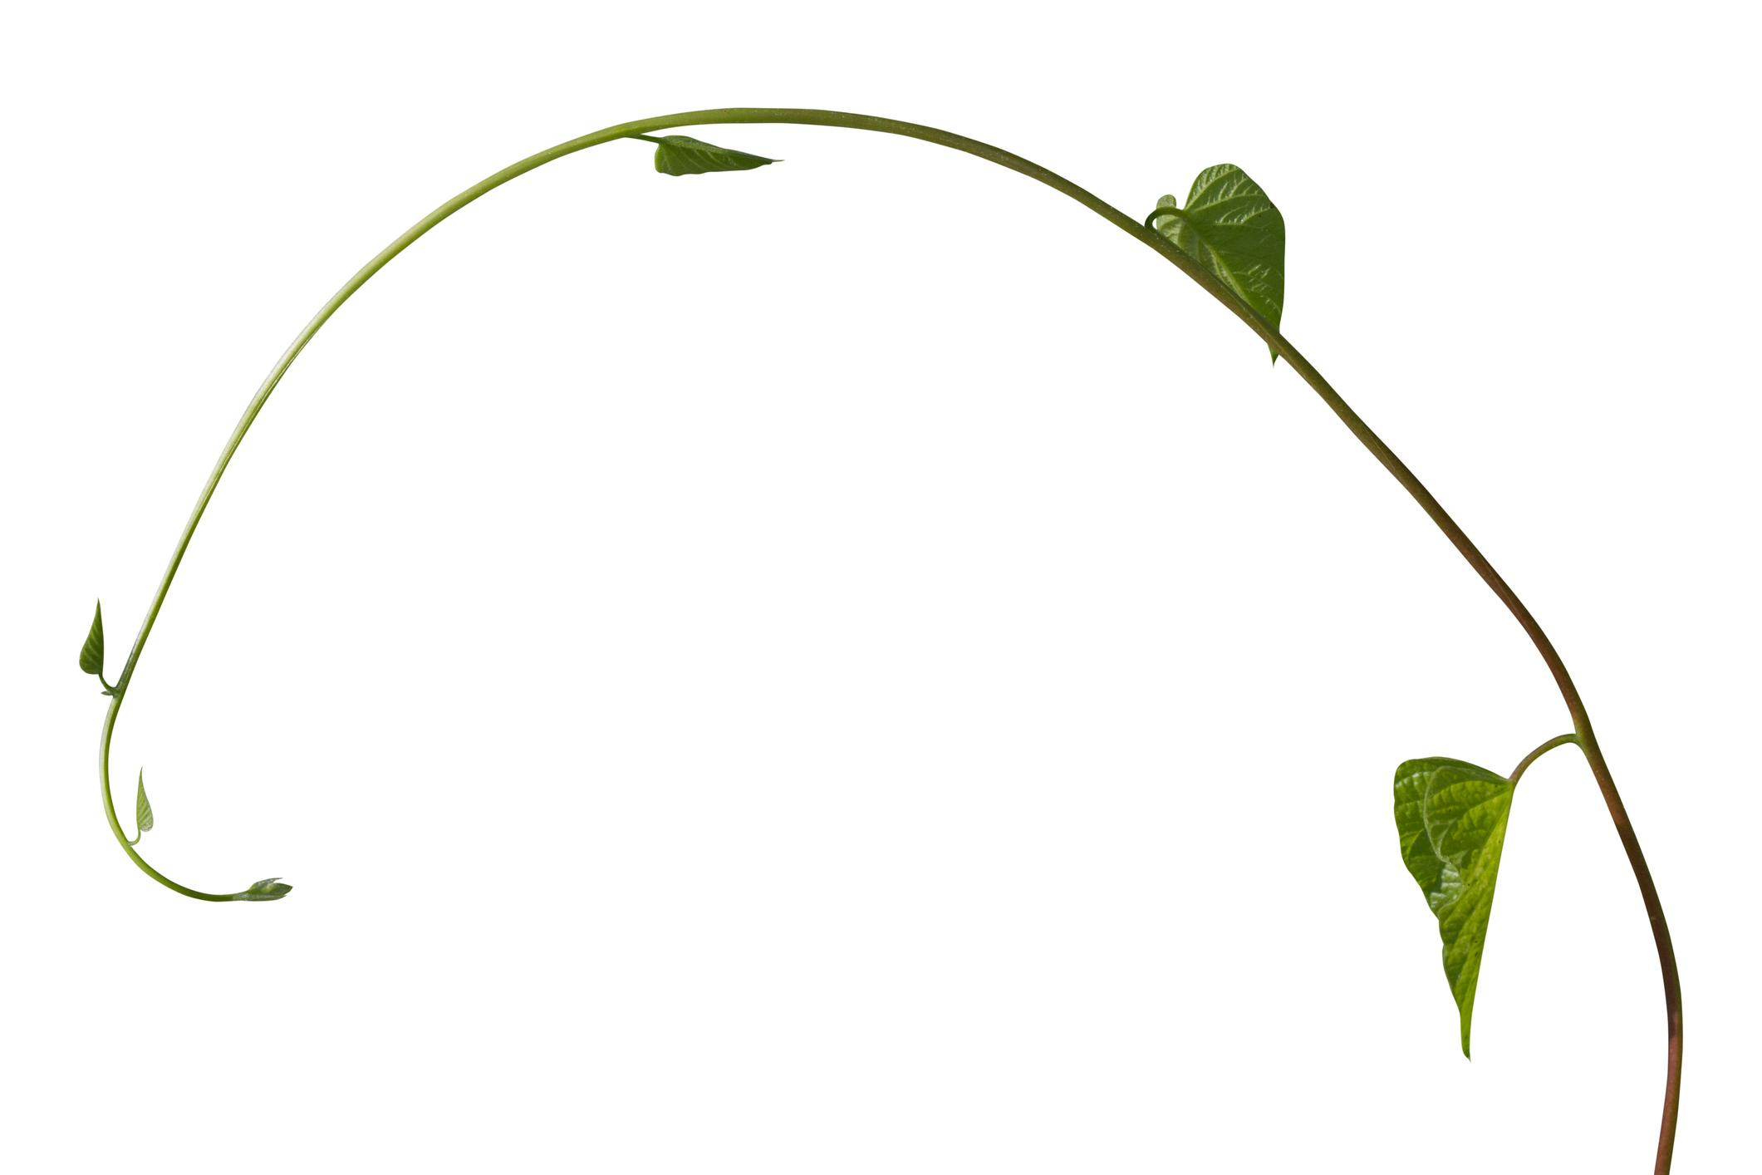
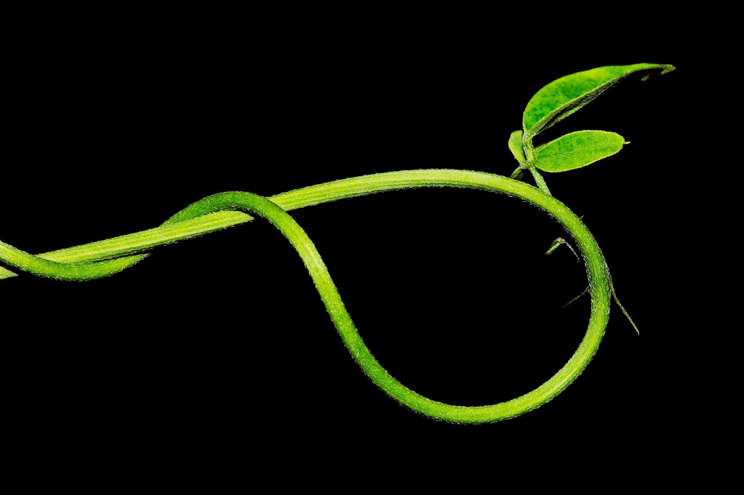
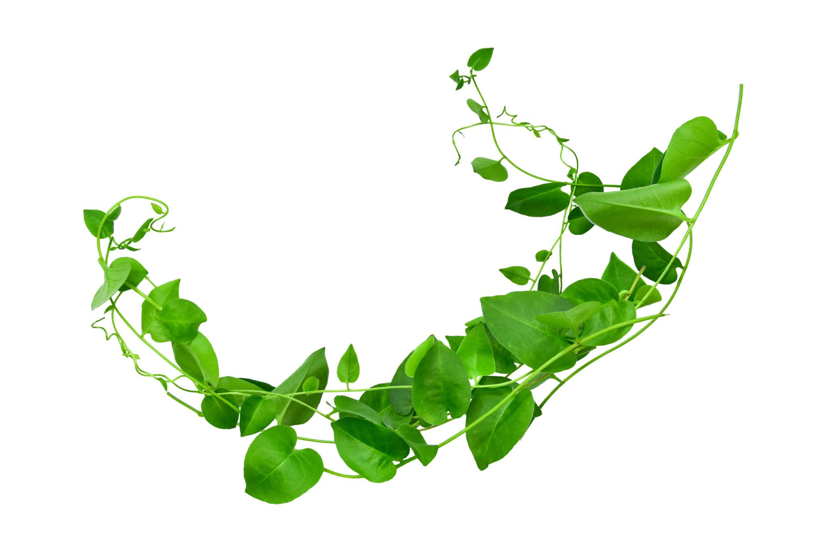
It may have mild winding or spiral-like behavior.

4. Root-Like Organic Open Curve
# Source: AI Source: Provided by: [Data Path: Persons Table -> ID Column: 1, Name_En Column: Motasem Essam] -> From: [ChatGPT] on [7/25/2026]
An irregular curved path resembling a root.
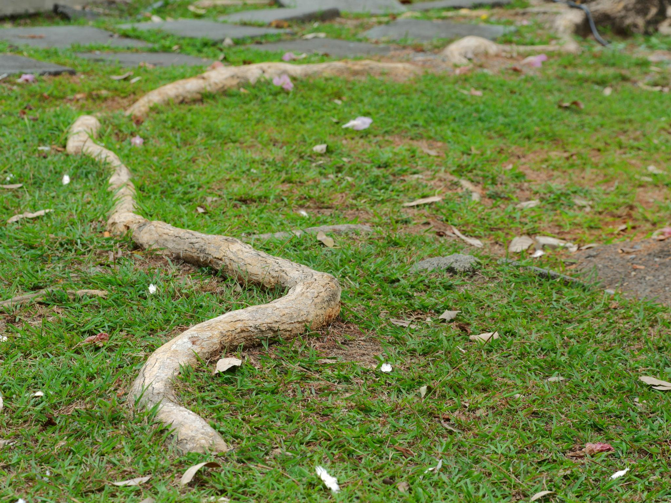
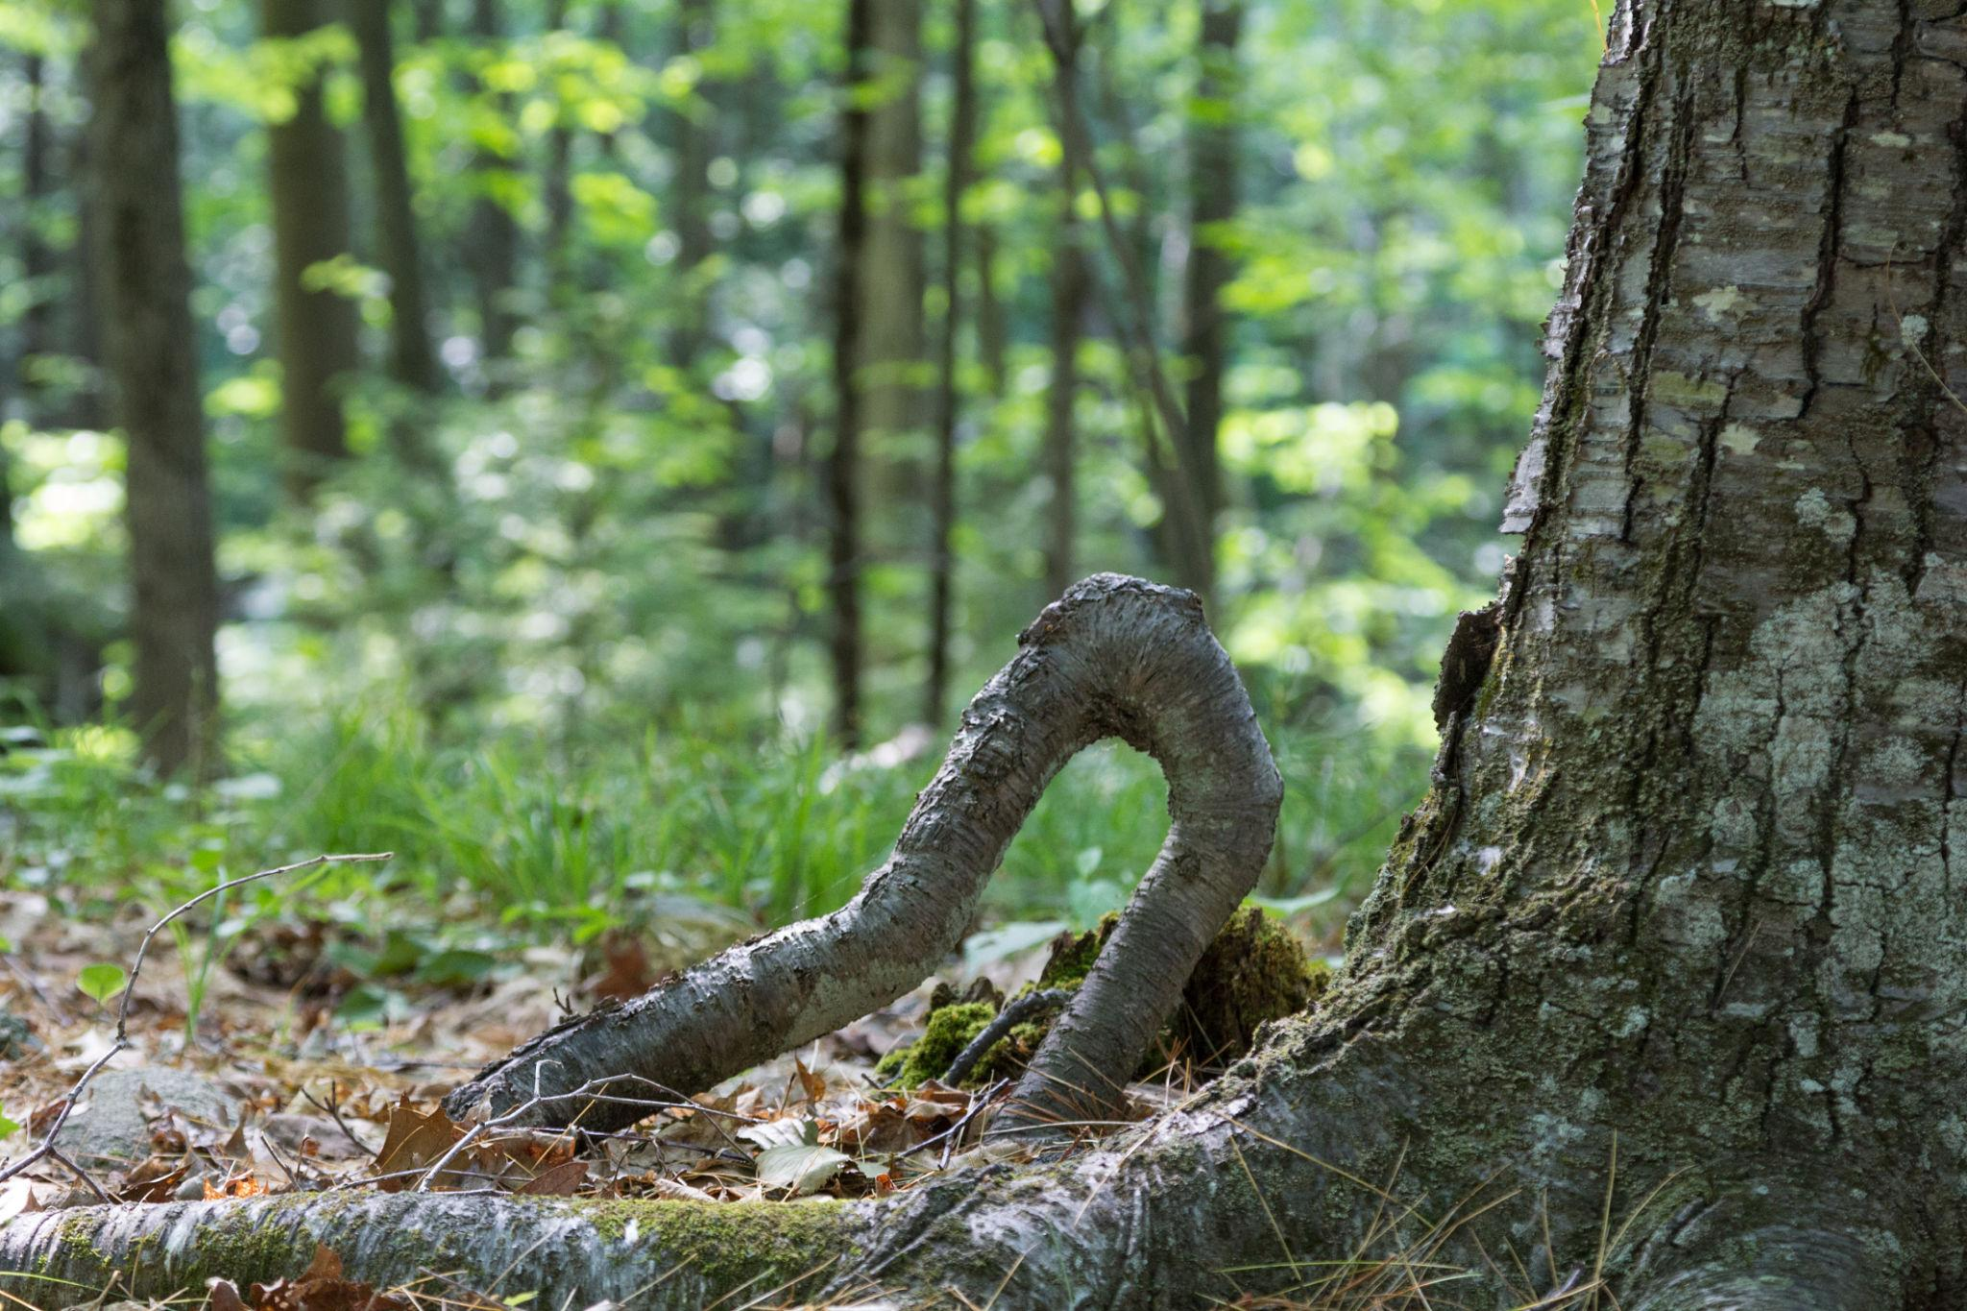
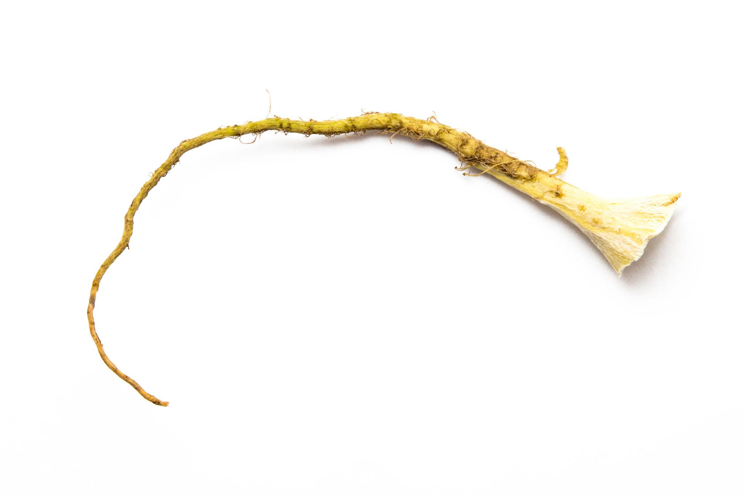
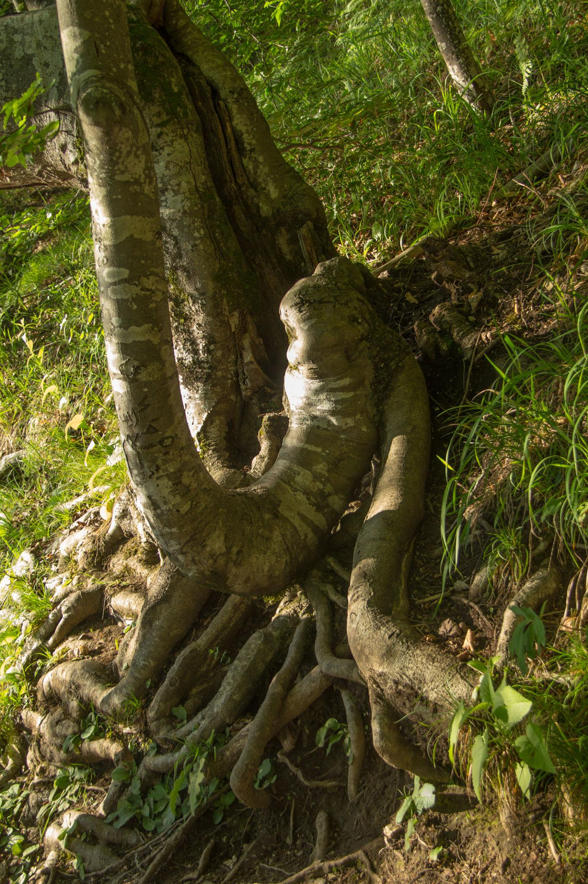
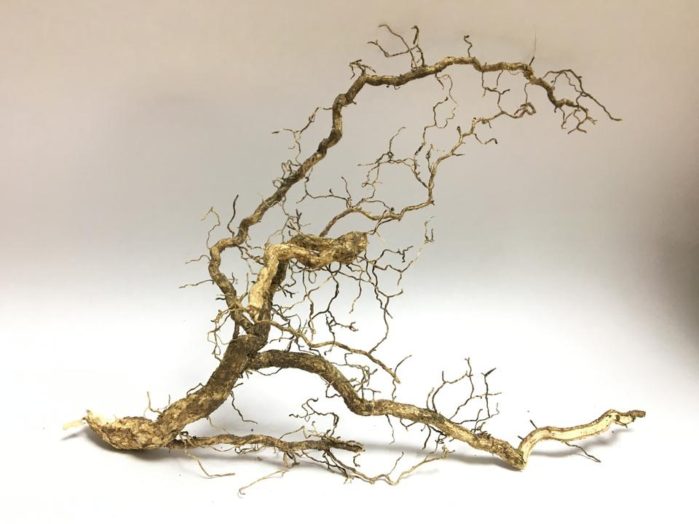
Its direction and curvature can change unpredictably.

5. Leaf-Edge Organic Open Curve
# Source: AI Source: Provided by: [Data Path: Persons Table -> ID Column: 1, Name_En Column: Motasem Essam] -> From: [ChatGPT] on [7/25/2026]
A portion of a leaf's naturally curved boundary.
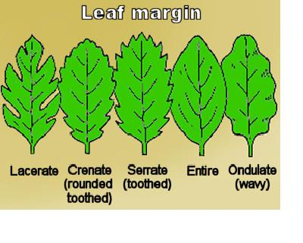
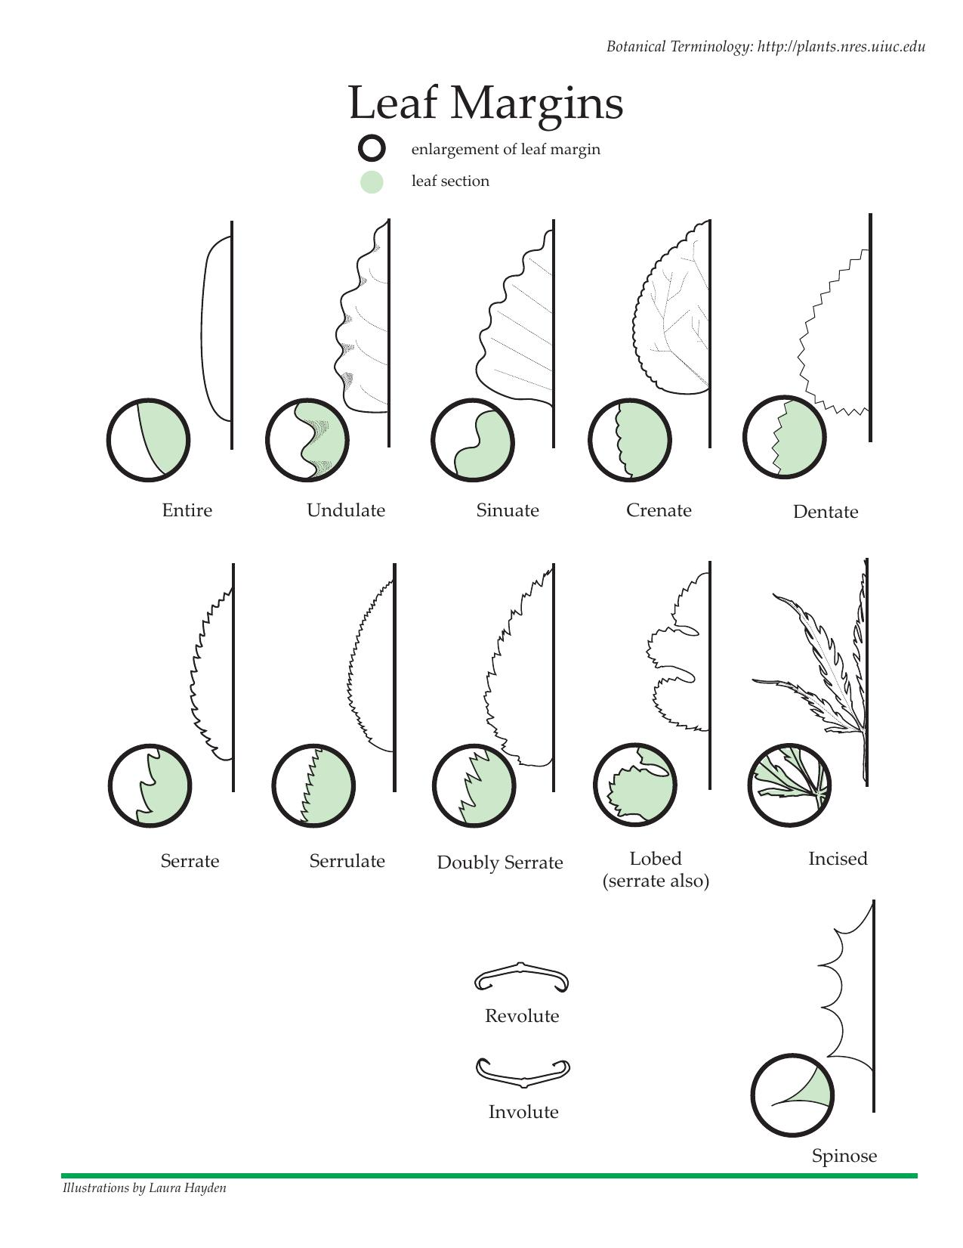
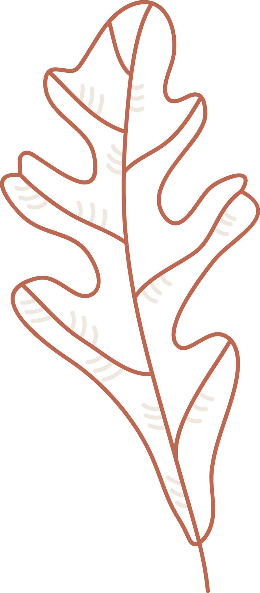
The selected boundary is open because only part of the leaf edge is being considered.

6. Coastline-Like Organic Open Curve
# Source: AI Source: Provided by: [Data Path: Persons Table -> ID Column: 1, Name_En Column: Motasem Essam] -> From: [ChatGPT] on [7/25/2026]
An irregular curved path resembling a portion of a natural coastline.
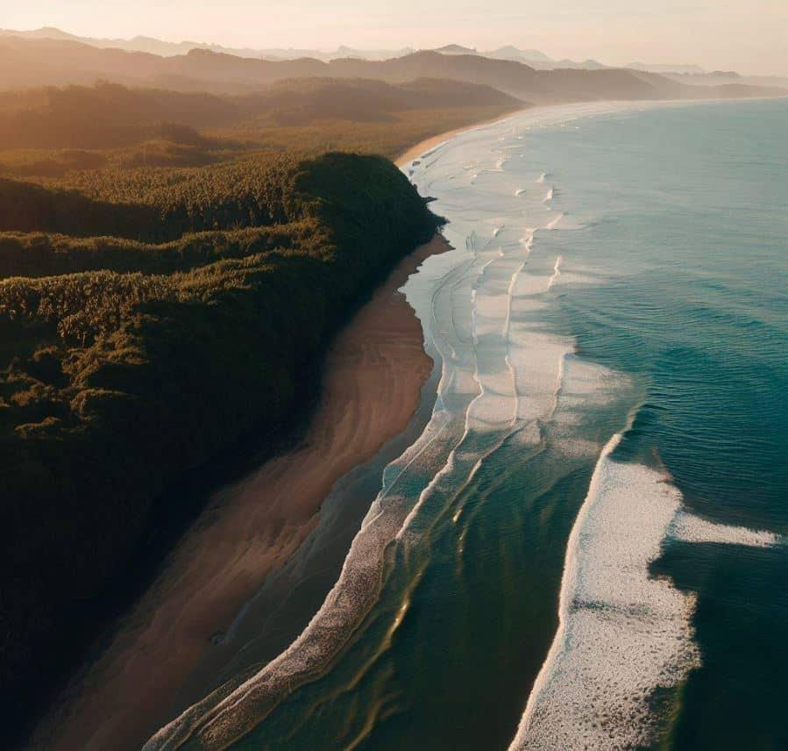
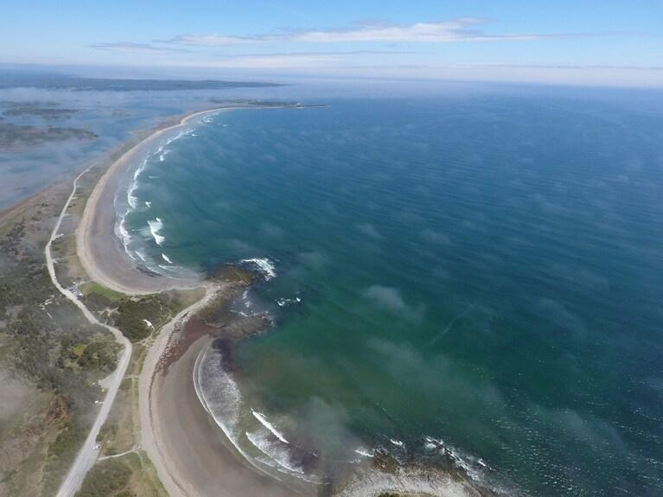

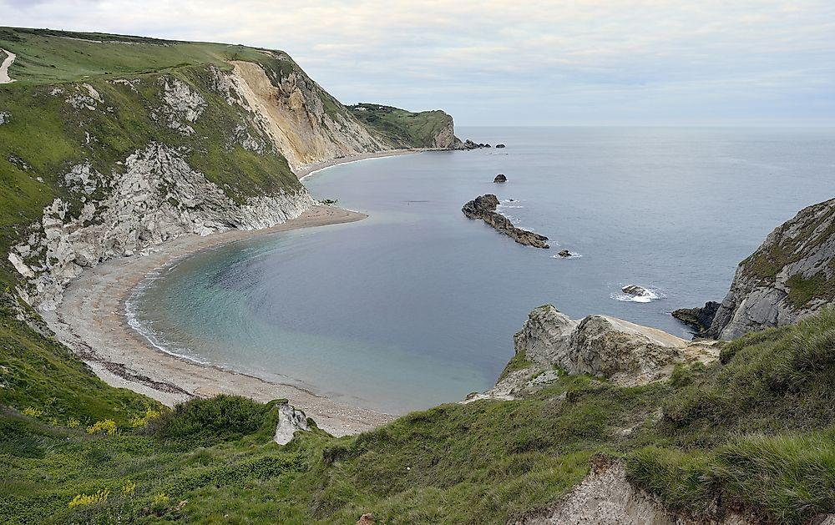
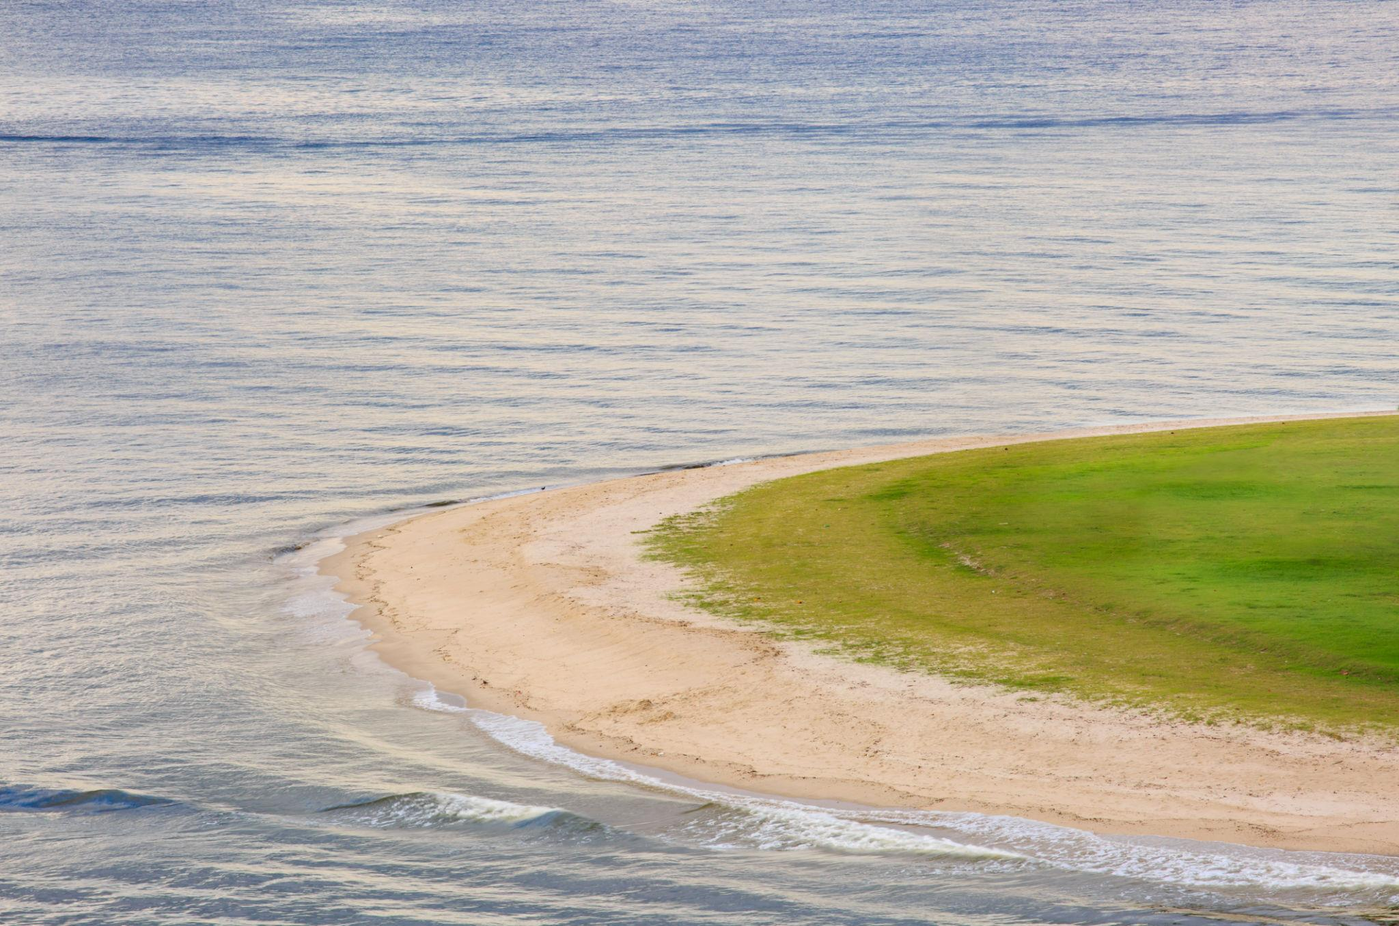
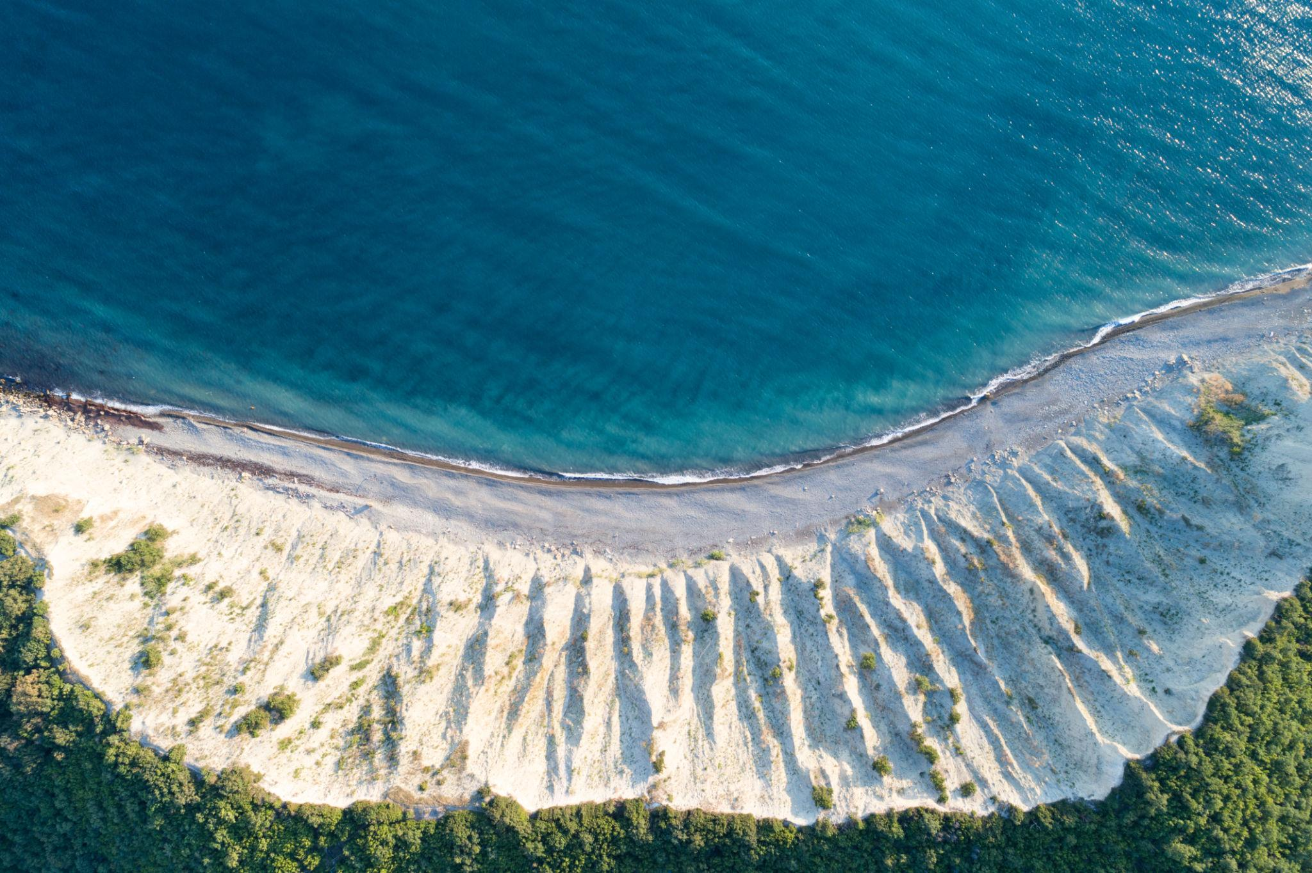
It typically contains irregular bends and changing curvature.

7. Flowing Organic Open Curve
# Source: AI Source: Provided by: [Data Path: Persons Table -> ID Column: 1, Name_En Column: Motasem Essam] -> From: [ChatGPT] on [7/25/2026]
A smooth, flowing curve that resembles water, smoke, fabric, or another naturally flowing form.
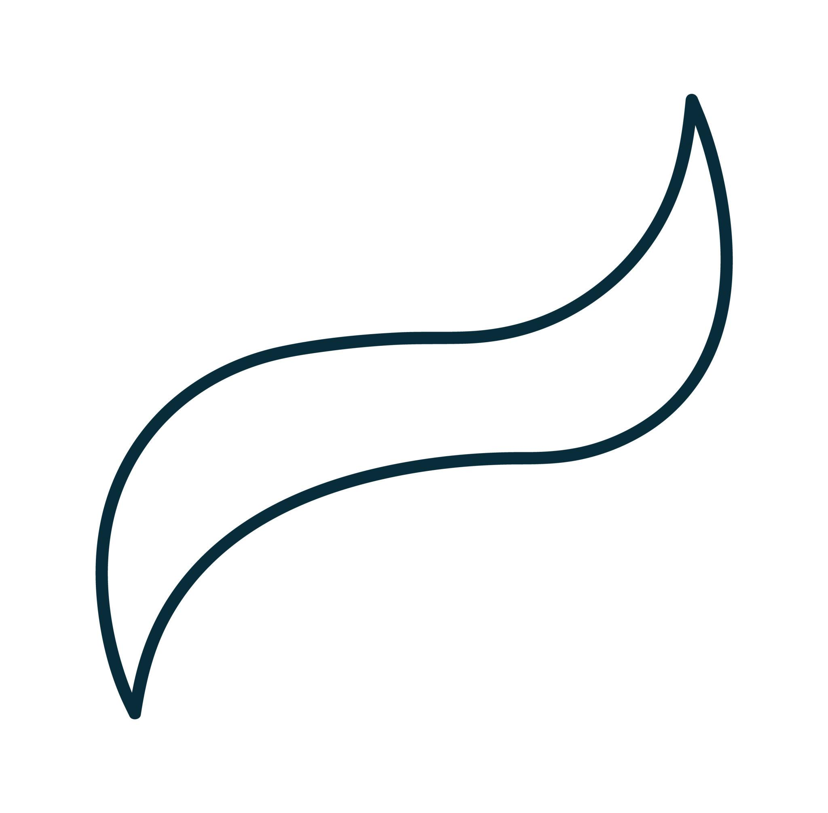
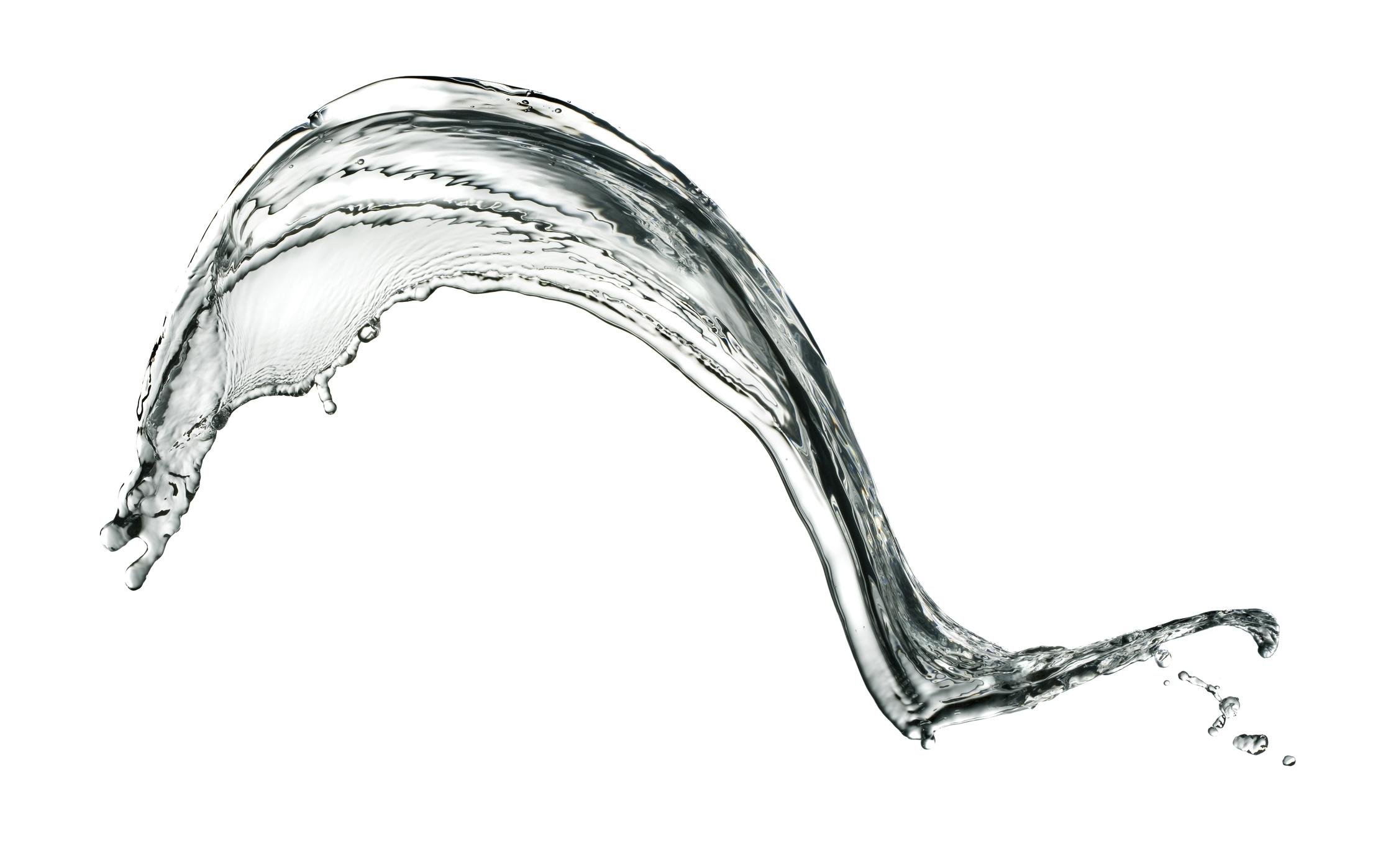
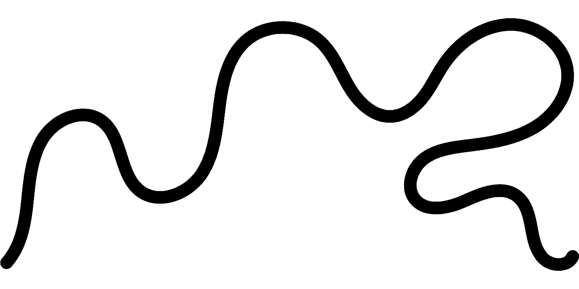
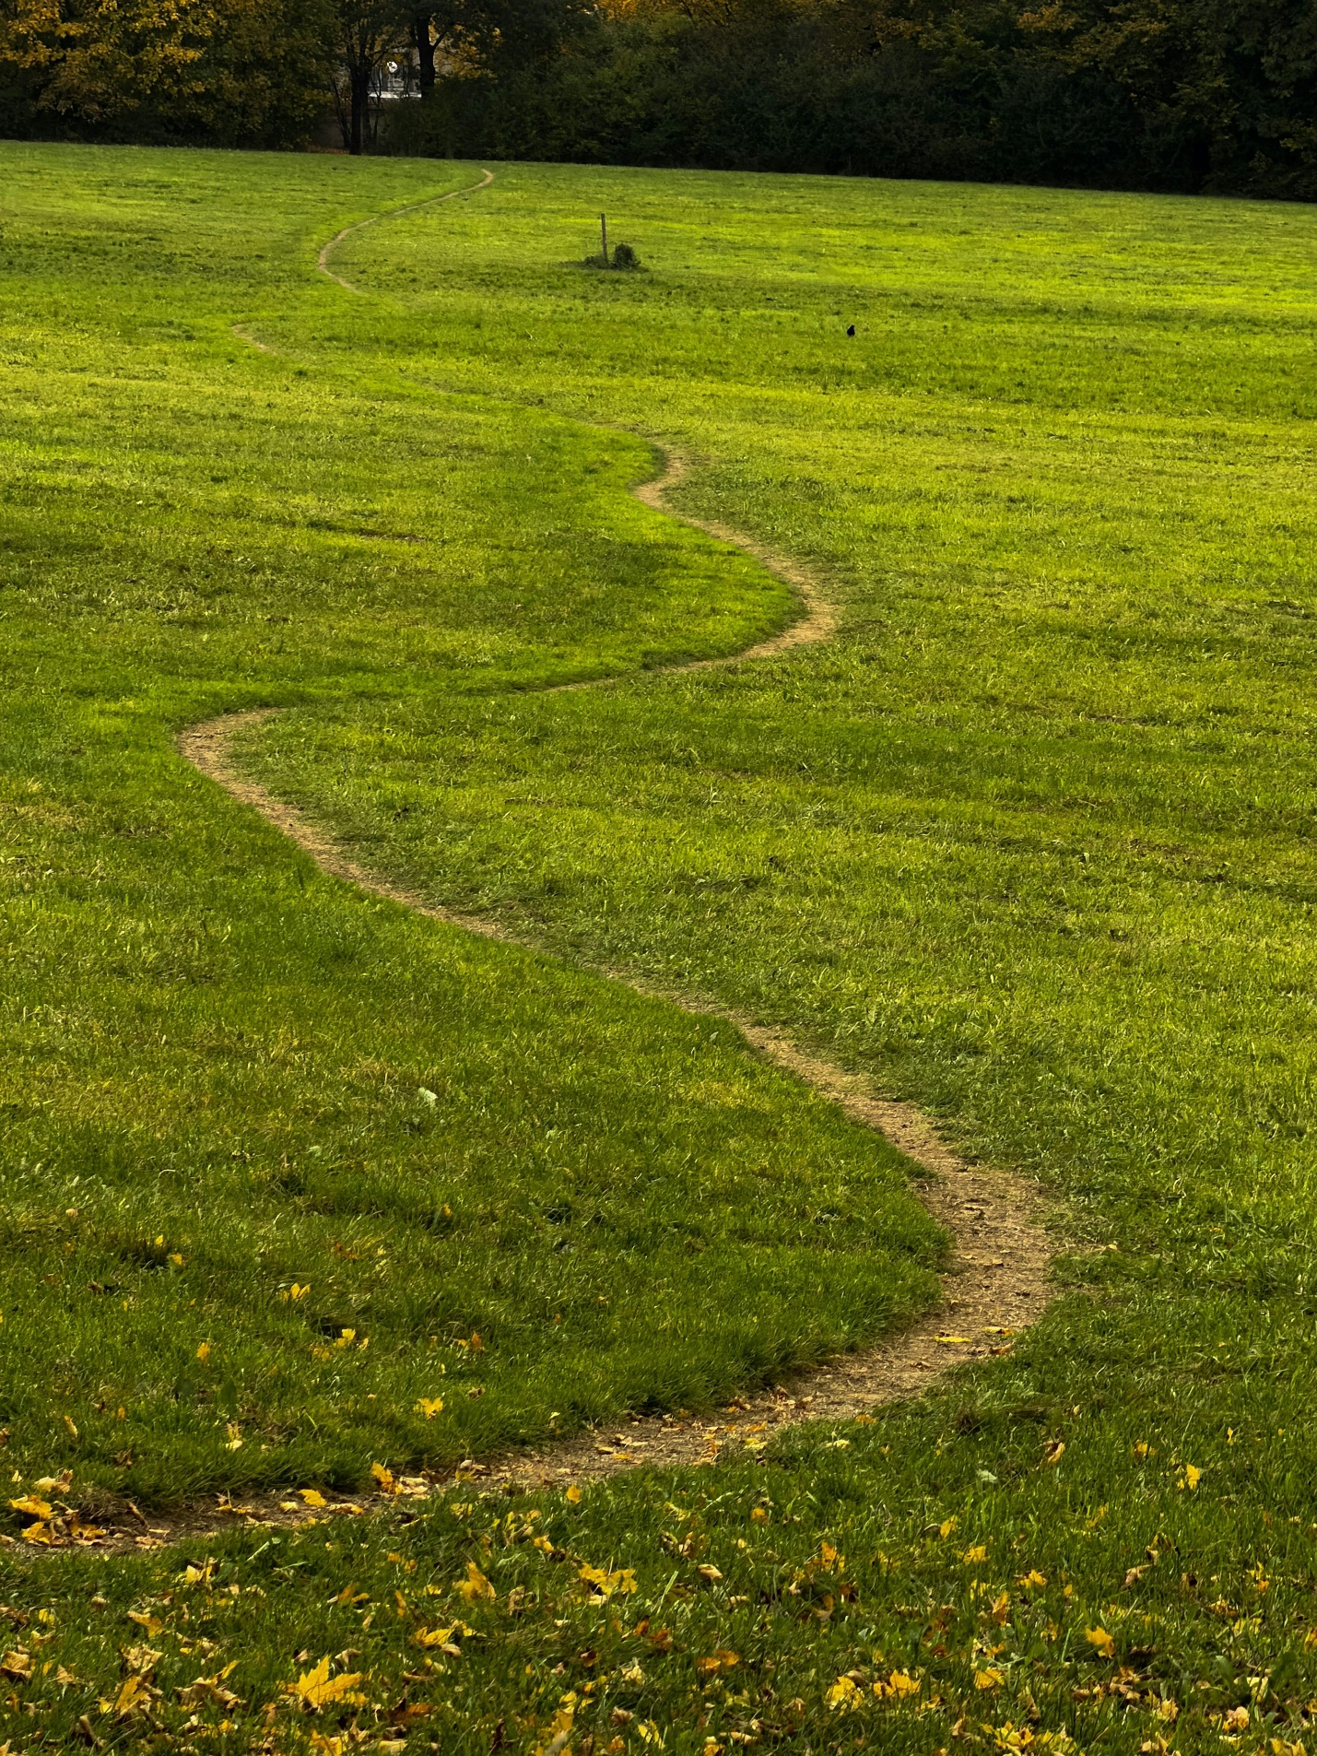
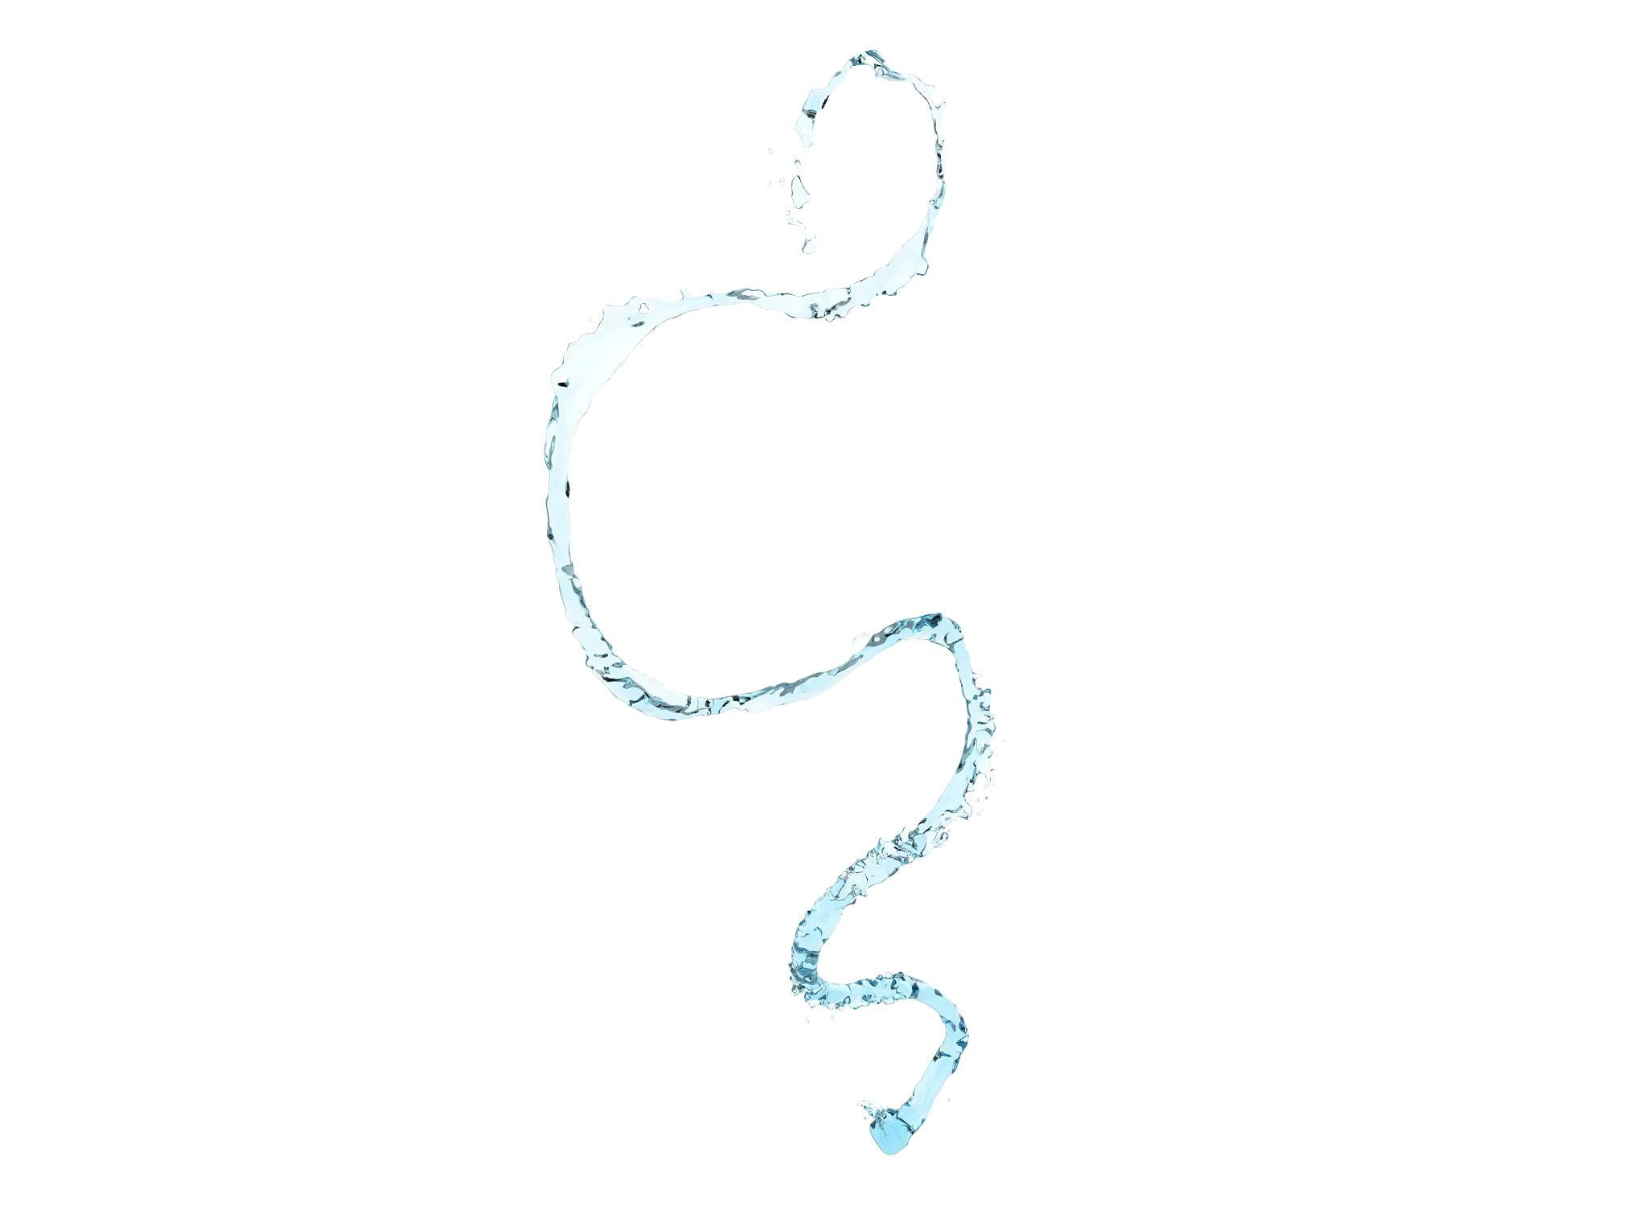
The curve generally has smooth transitions rather than sharp corners.

8. Wavy Organic Open Curve
# Source: AI Source: Provided by: [Data Path: Persons Table -> ID Column: 1, Name_En Column: Motasem Essam] -> From: [ChatGPT] on [7/25/2026]
An organic curve with repeated but irregular undulations.
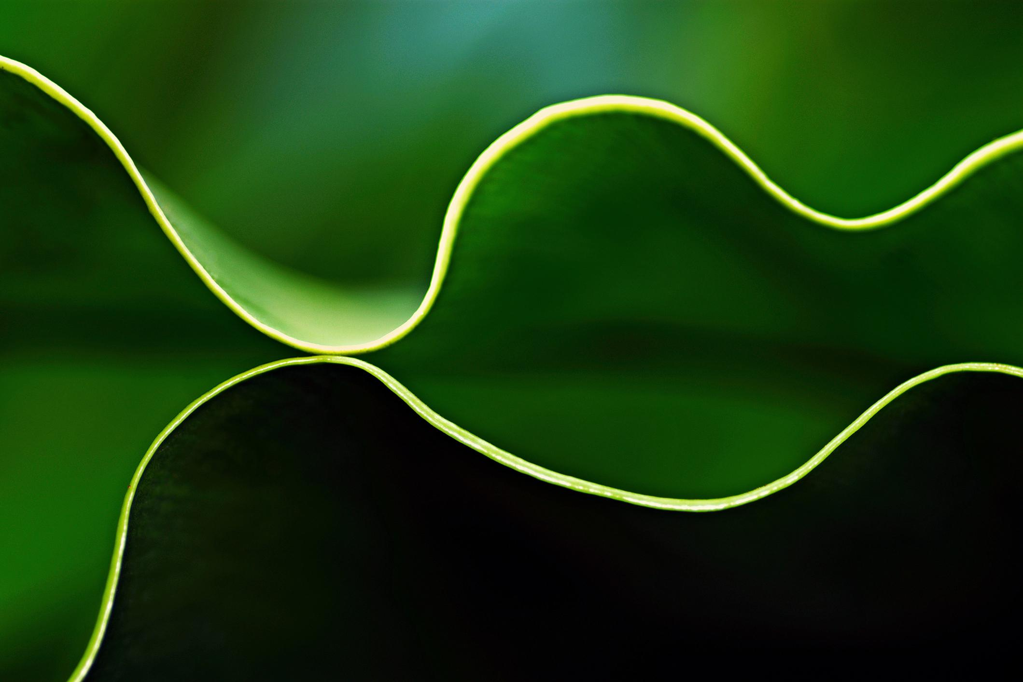
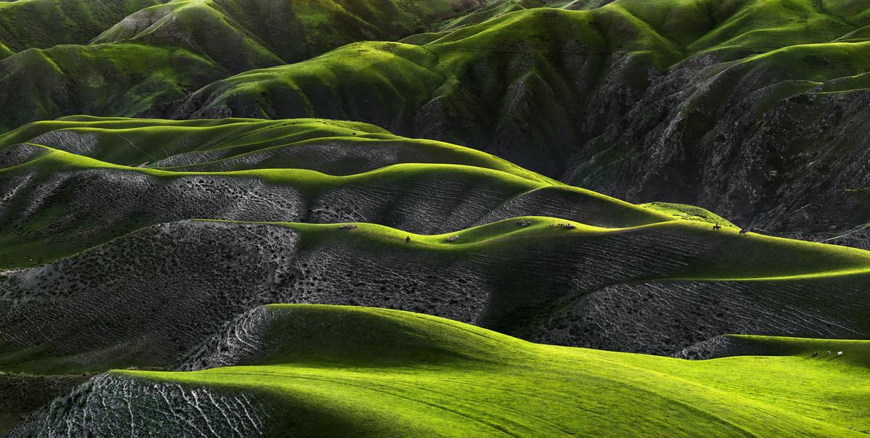
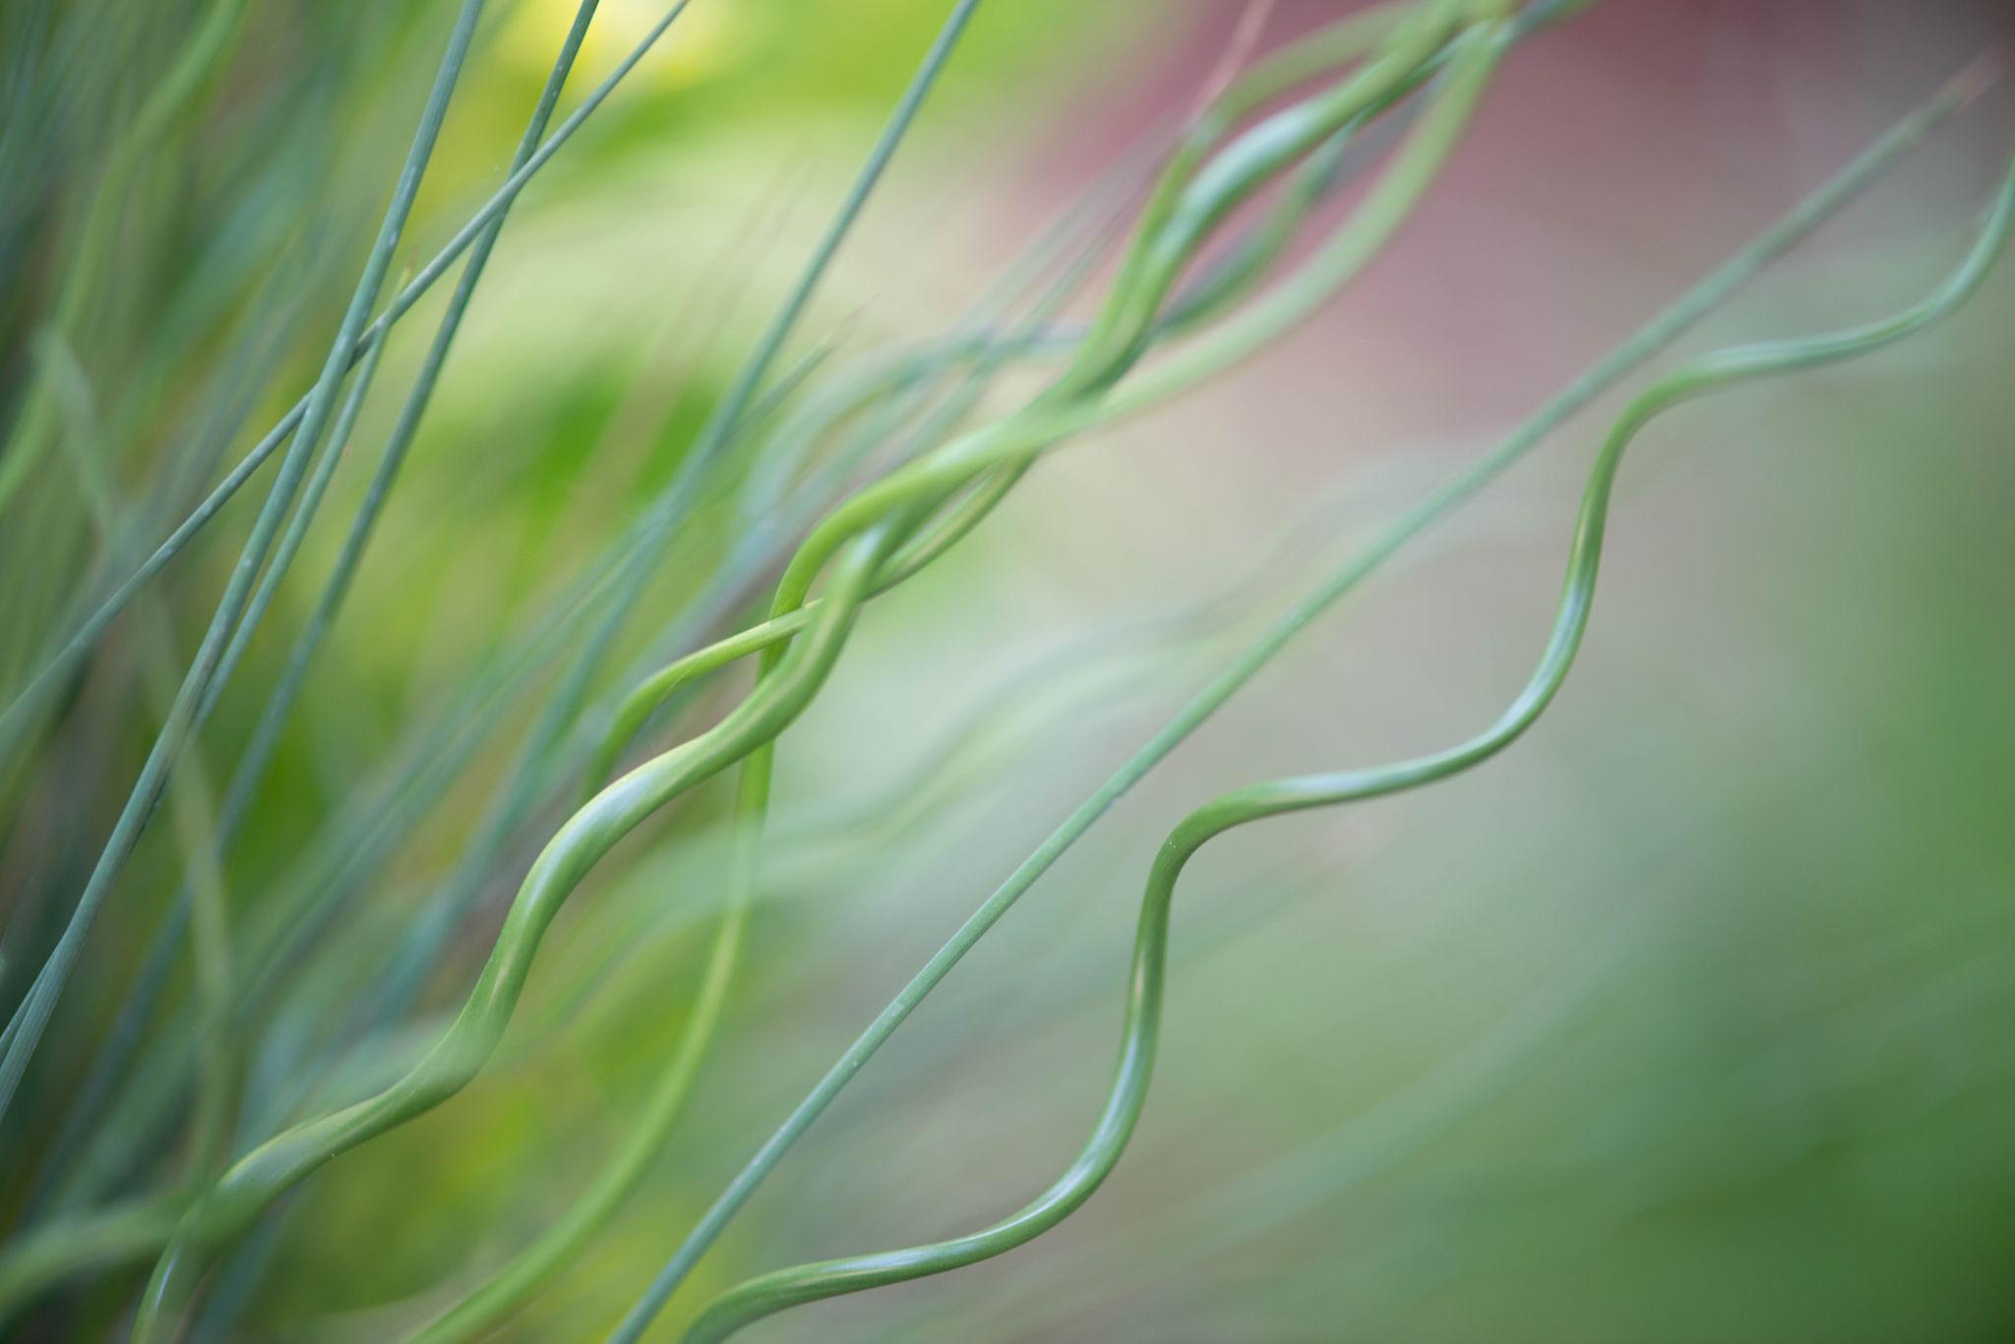
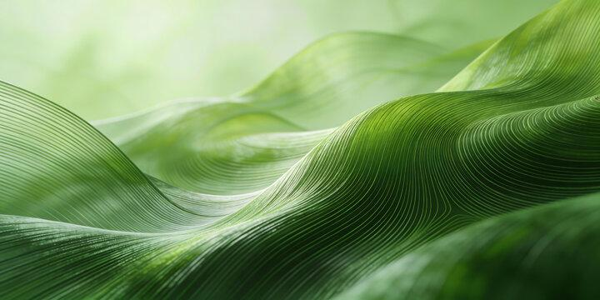
The waves are not necessarily mathematically regular.

9. Spiral-Like Organic Open Curve
# Source: AI Source: Provided by: [Data Path: Persons Table -> ID Column: 1, Name_En Column: Motasem Essam] -> From: [ChatGPT] on [7/25/2026]
An organic curve that winds around a region while maintaining a natural, irregular appearance.
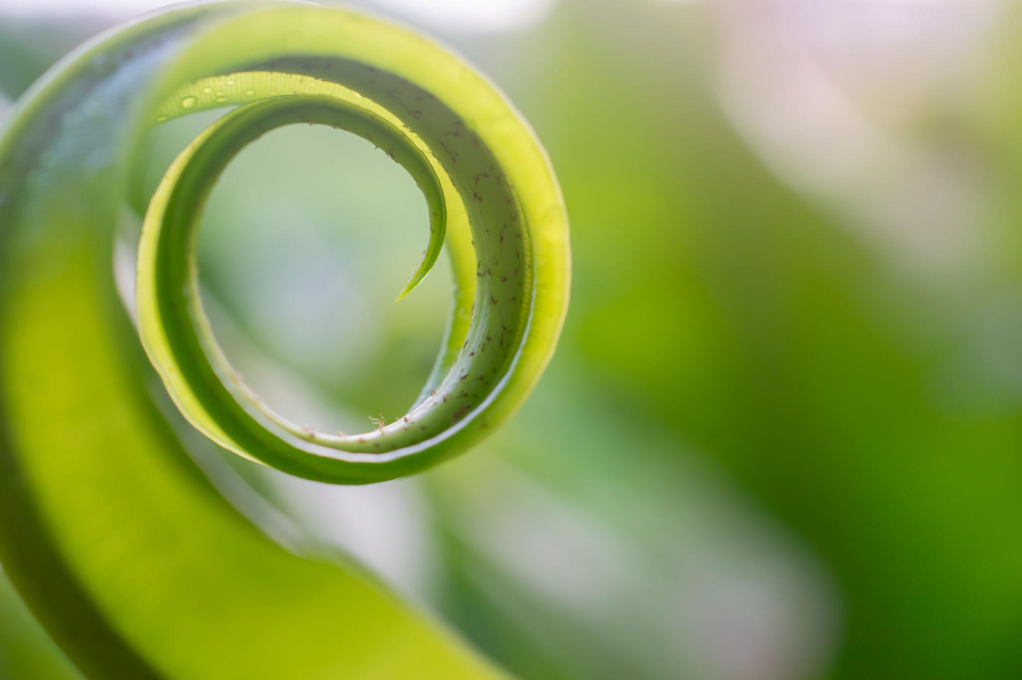
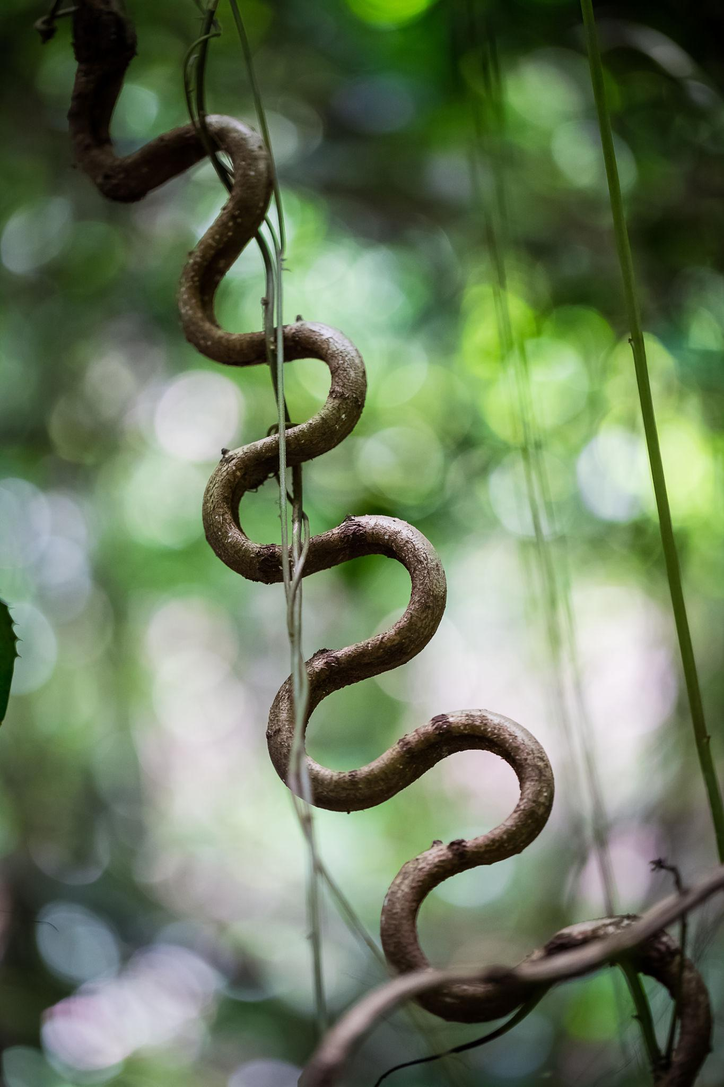
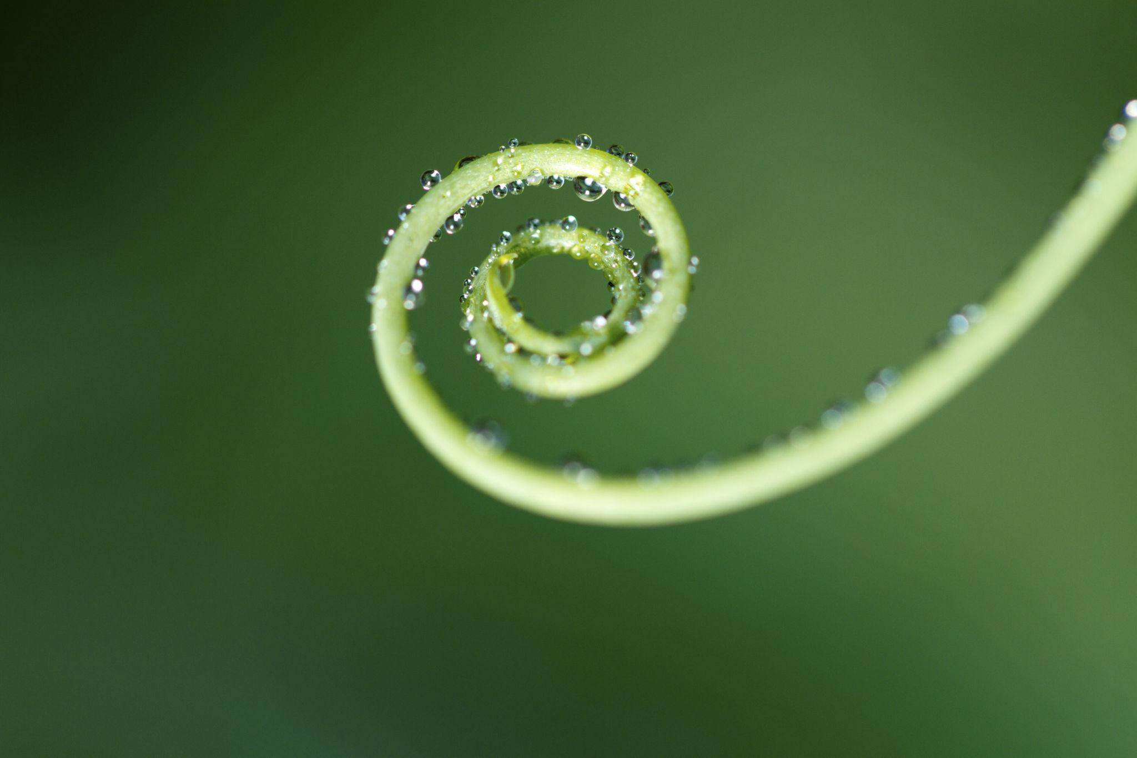
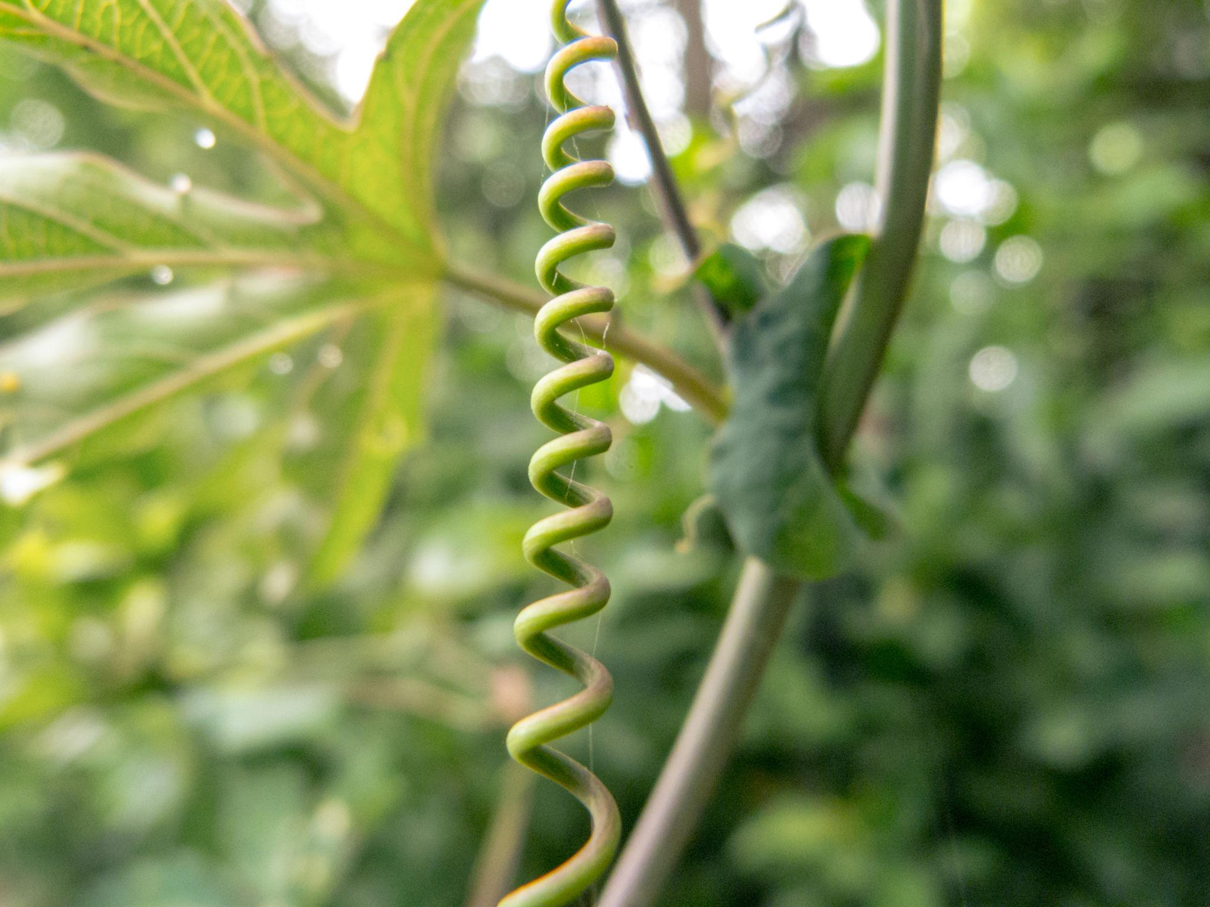
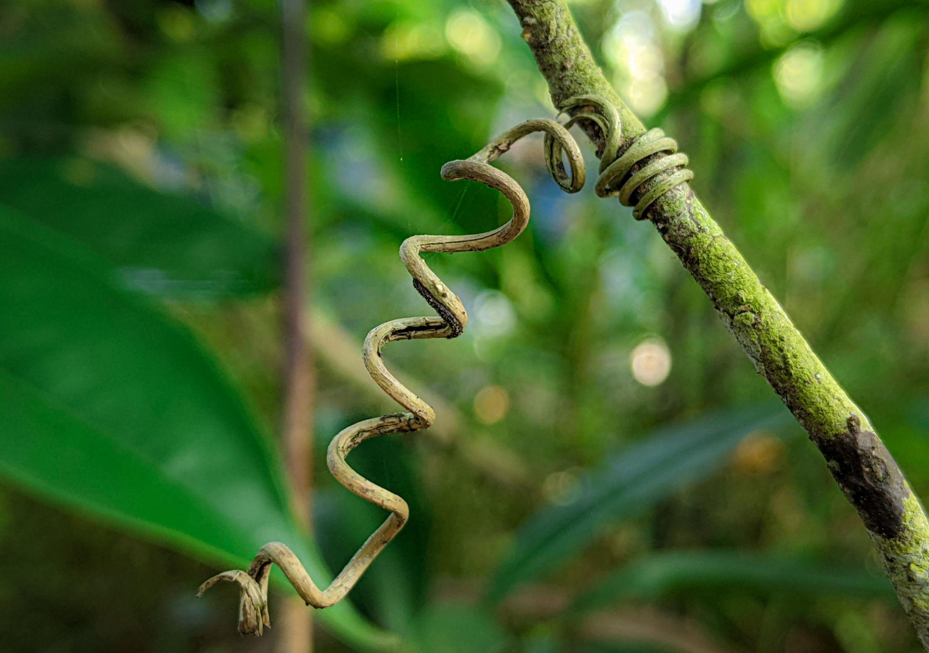
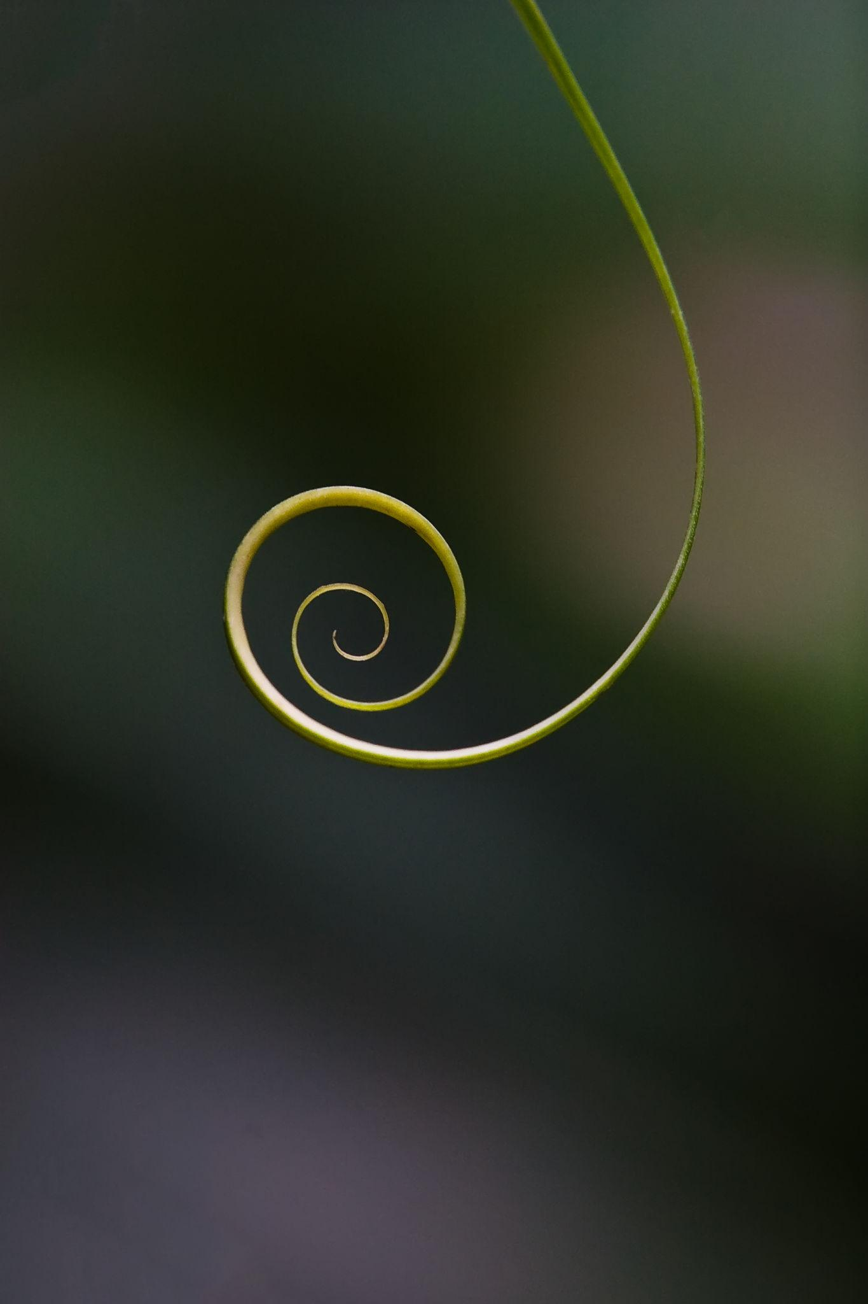
Examples include portions of vines, tendrils, and natural growth patterns.

10. Asymmetric Organic Open Curve
# Source: AI Source: Provided by: [Data Path: Persons Table -> ID Column: 1, Name_En Column: Motasem Essam] -> From: [ChatGPT] on [7/25/2026]
An organic curve without recognizable mirror or rotational symmetry.
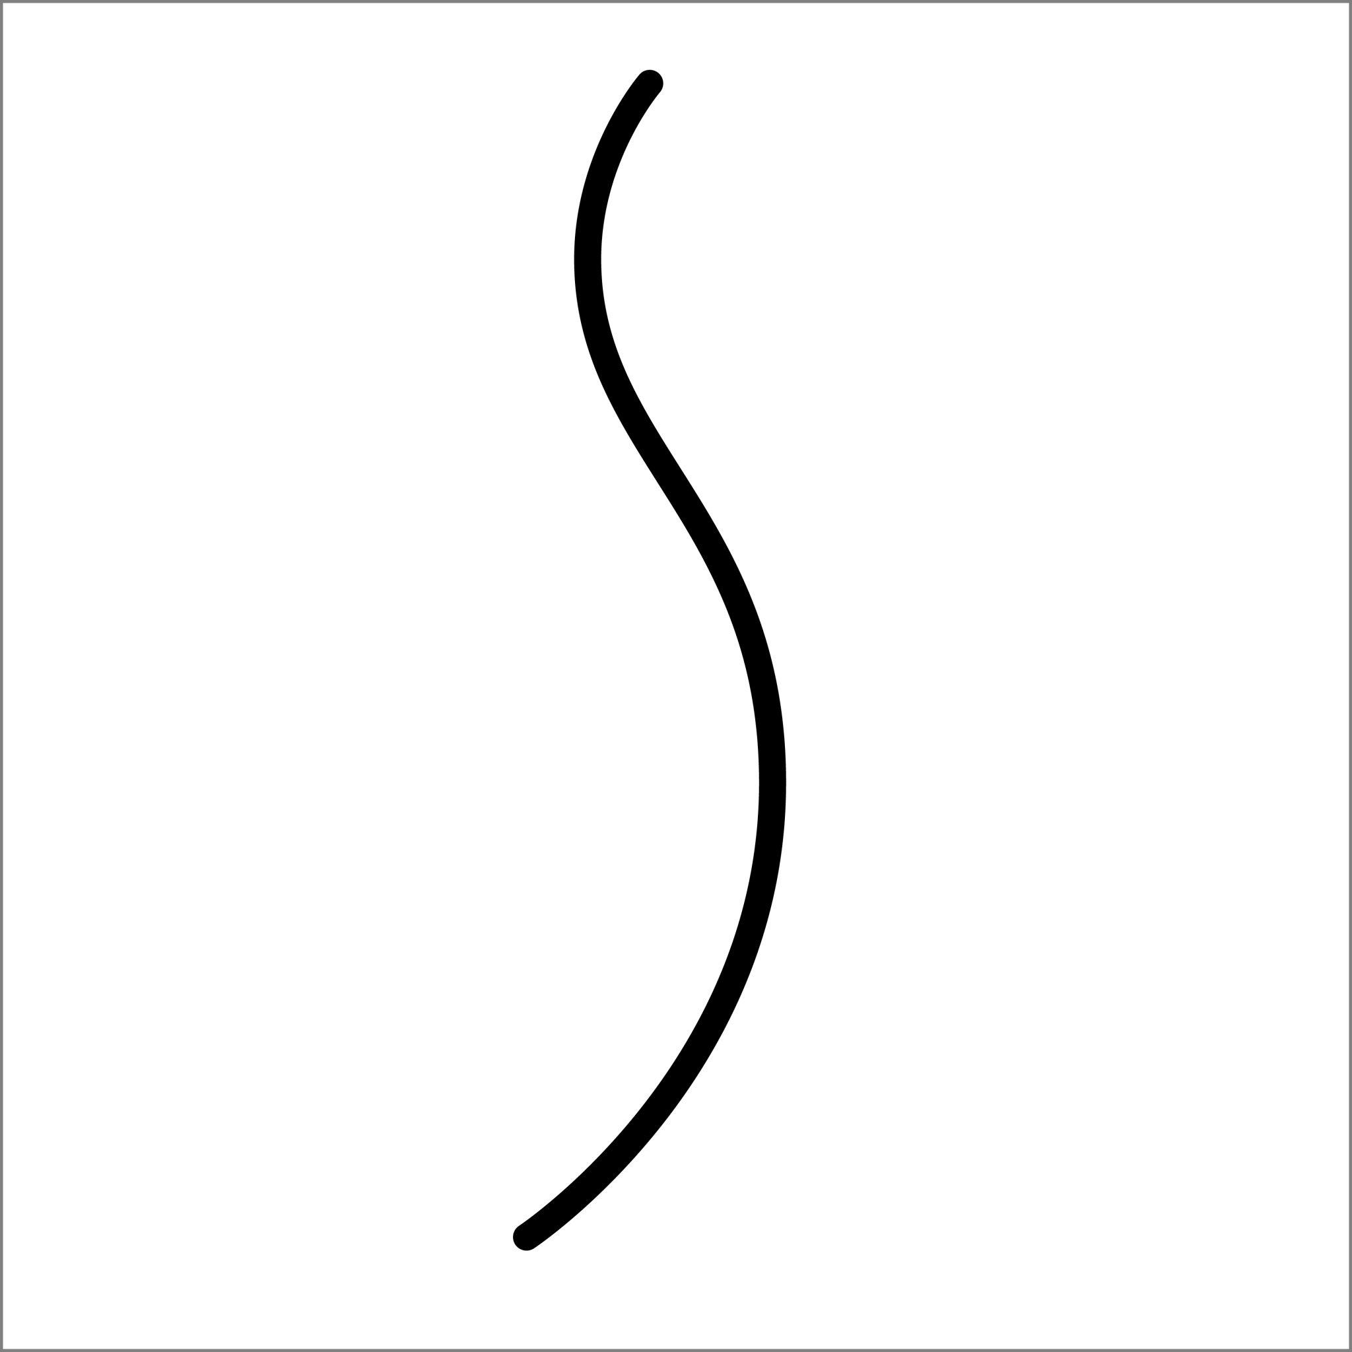
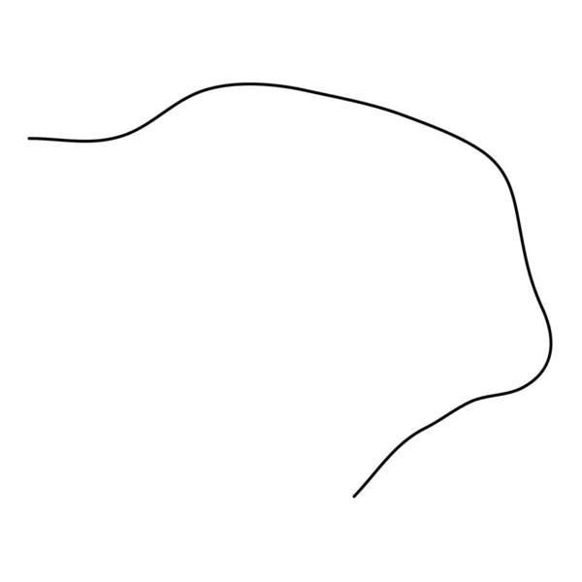
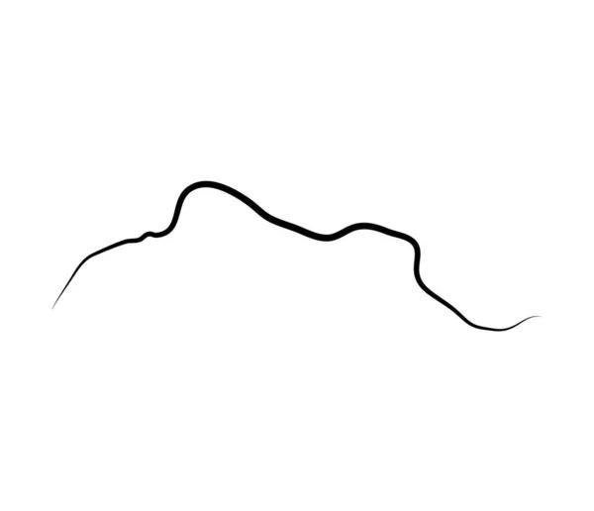
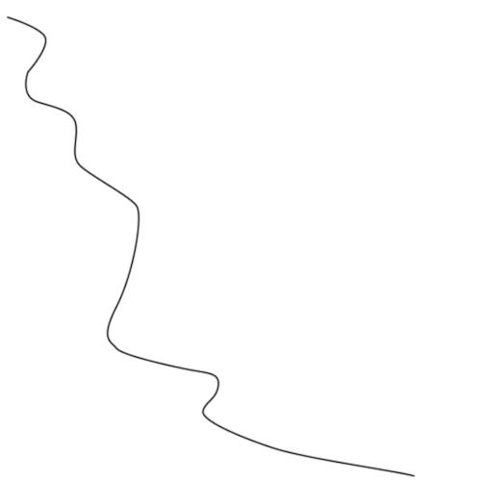
Asymmetry is very common in naturally occurring curves.

11. Smooth Organic Open Curve
# Source: AI Source: Provided by: [Data Path: Persons Table -> ID Column: 1, Name_En Column: Motasem Essam] -> From: [ChatGPT] on [7/25/2026]
A natural-looking curve with gradual changes in direction and no sharp corners.
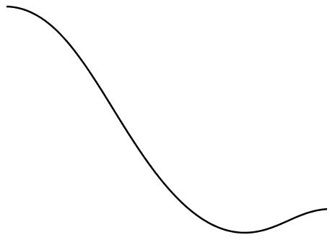
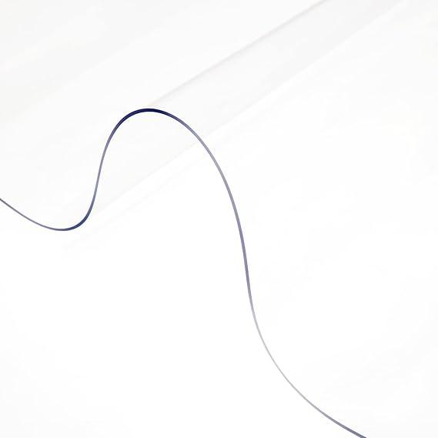
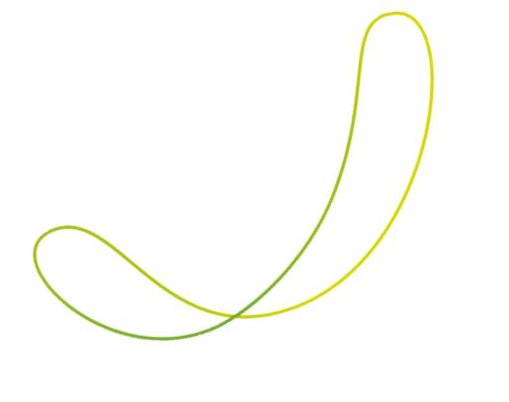
This is useful for distinguishing flowing organic forms from angular polygonal shapes.

12. Irregular Organic Open Curve
# Source: AI Source: Provided by: [Data Path: Persons Table -> ID Column: 1, Name_En Column: Motasem Essam] -> From: [ChatGPT] on [7/25/2026]
A highly irregular open curve with varying curvature and no simple repeating pattern.
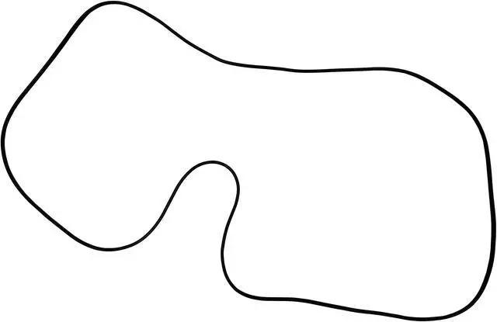
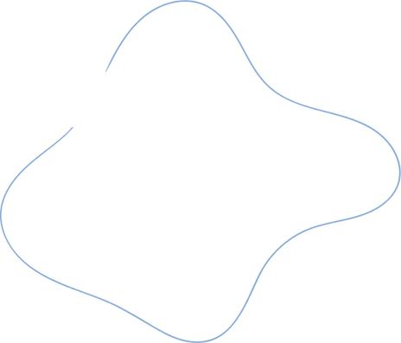
This is the broadest category of organic open curves.

Organic Open Curve vs. Freeform Open Curve
# Source: AI Source: Provided by: [Data Path: Persons Table -> ID Column: 1, Name_En Column: Motasem Essam] -> From: [ChatGPT] on [7/25/2026]
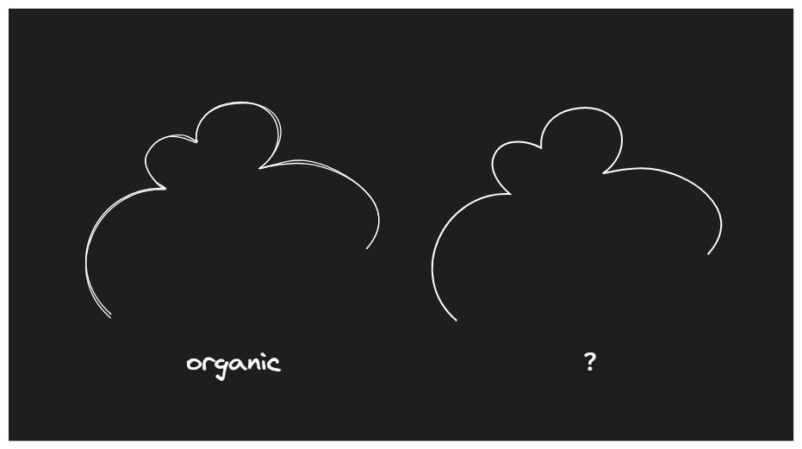
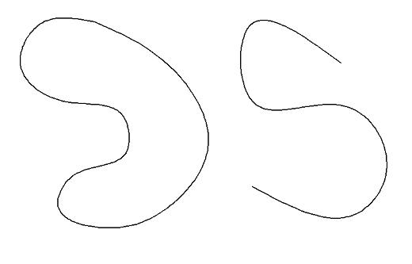
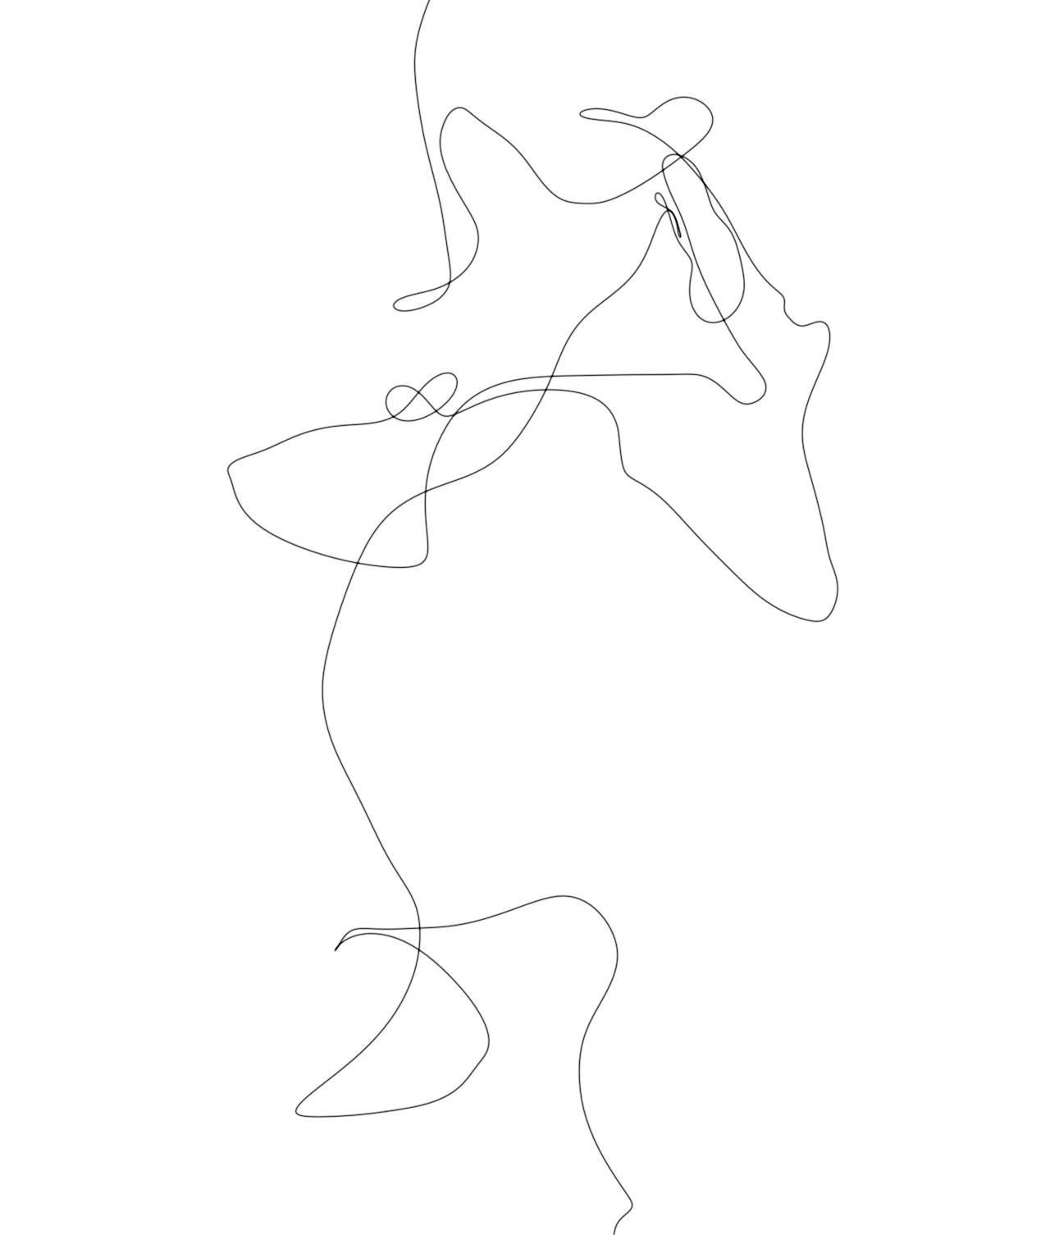
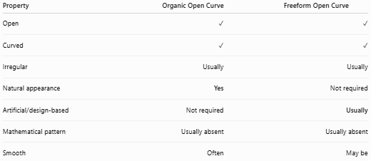
Property | Organic Open Curve | Freeform Open Curve
Open | ✓ | ✓
Curved | ✓ | ✓
Irregular | Usually | Usually
Natural appearance | Yes | Not required
Artificial/design-based | Not required | Usually
Mathematical pattern | Usually absent | Usually absent
Smooth | Often | May be
Main distinction:
$$\boxed{\text{Organic}=\text{Natural-Looking}} \\ \boxed{\text{Freeform}=\text{Freely Designed}}$$

Organic Open Curve vs. Wavy Open Curve
# Source: AI Source: Provided by: [Data Path: Persons Table -> ID Column: 1, Name_En Column: Motasem Essam] -> From: [ChatGPT] on [7/25/2026]
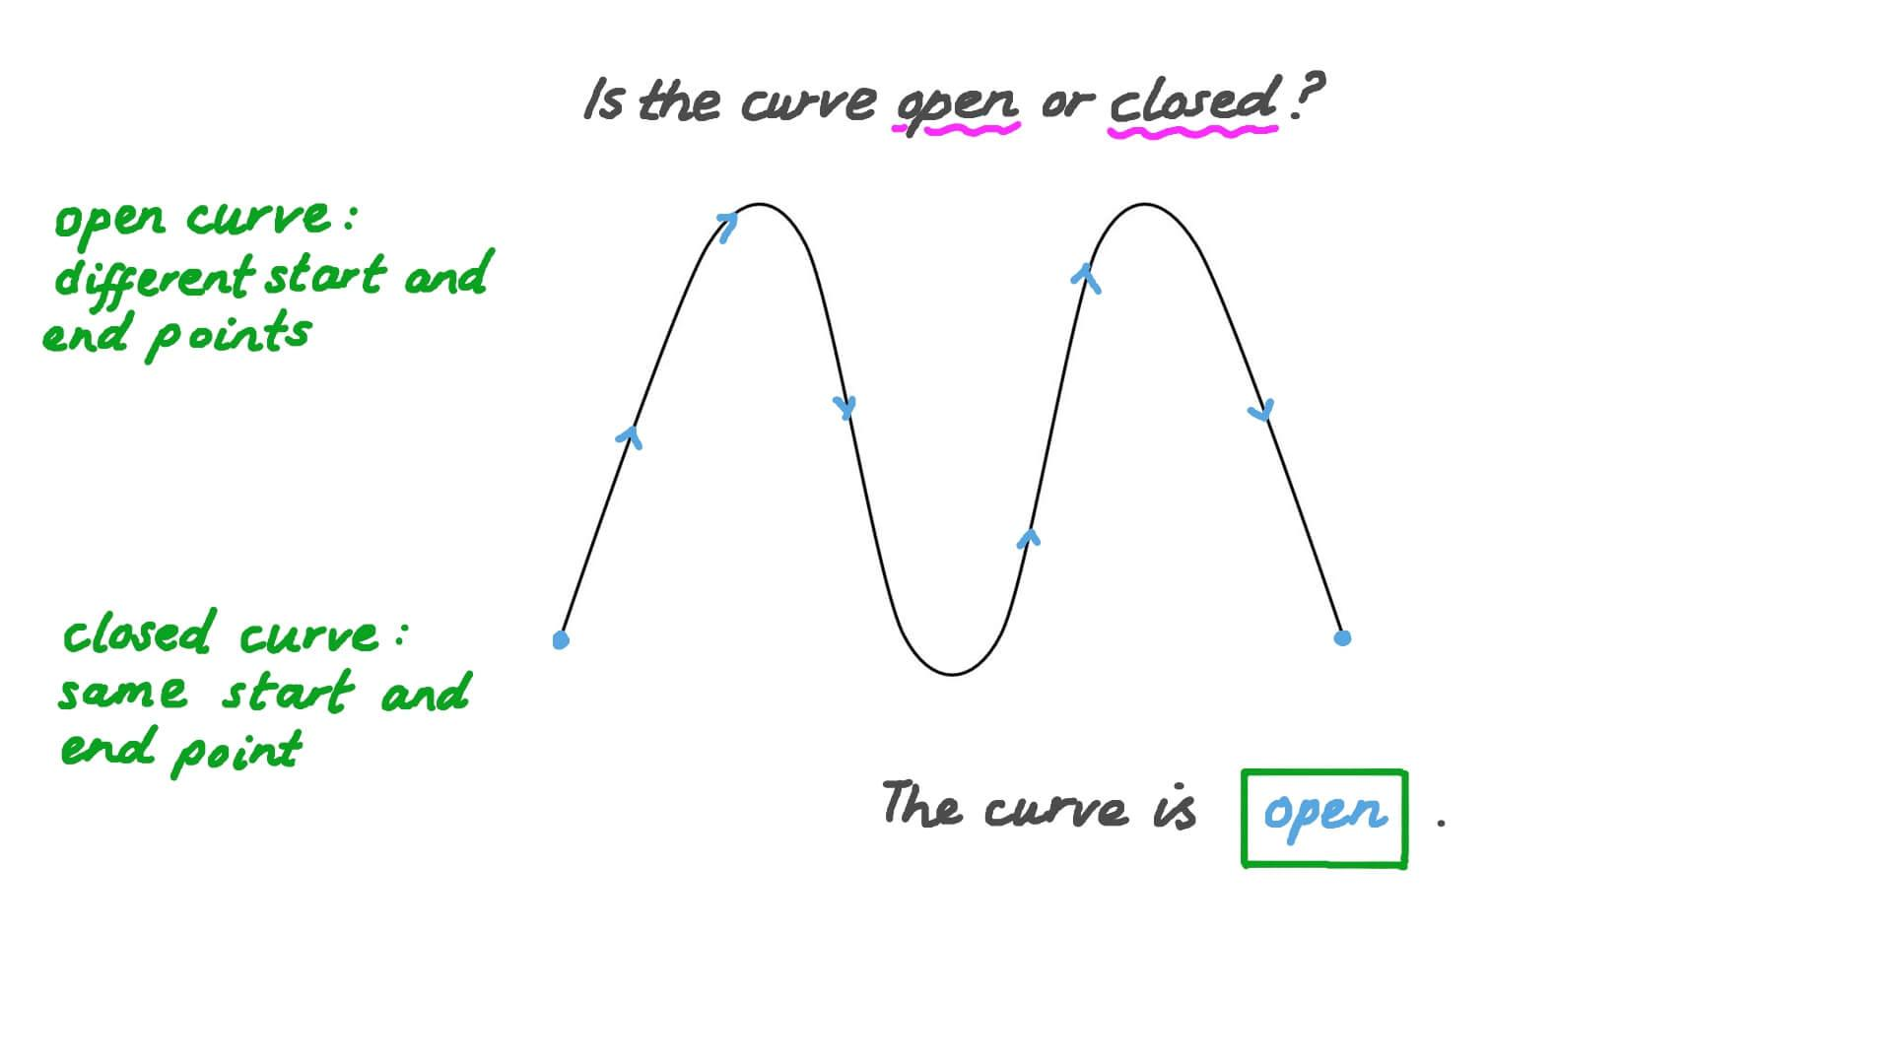
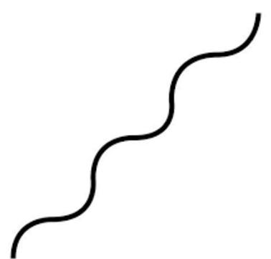
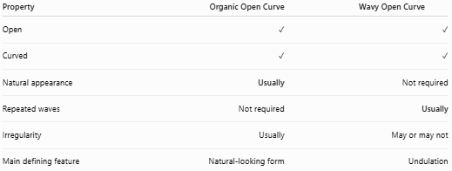
Property | Organic Open Curve | Wavy Open Curve
Open | ✓ | ✓
Curved | ✓ | ✓
Natural appearance | Usually | Not required
Repeated waves | Not required | Usually
Irregularity | Usually | May or may not
Main defining feature | Natural-looking form | Undulation

Key Points
# Source: AI Source: Provided by: [Data Path: Persons Table -> ID Column: 1, Name_En Column: Motasem Essam] -> From: [ChatGPT] on [7/25/2026]
An Organic Open Curve is:
$$\boxed{\text{Open}+\text{Curved}+\text{Irregular}+\text{Natural-Looking}}$$
It:
- Has two endpoints.
- Does not form a closed boundary.
- Has predominantly curved geometry.
- Usually has irregular curvature.
- Often resembles a natural or living form.
- May be smooth, wavy, winding, or asymmetric.
- Does not need to follow a mathematical equation.
- Does not enclose an area by itself.

Conclusion
# Source: AI Source: Provided by: [Data Path: Persons Table -> ID Column: 1, Name_En Column: Motasem Essam] -> From: [ChatGPT] on [7/25/2026]
Organic Open Curves are open curved forms distinguished primarily by their natural, flowing, and irregular appearance. They include branch-like, vine-like, root-like, coastline-like, flowing, wavy, and other naturally inspired curves. The key distinction from other open curved shapes is that "organic" describes the natural-looking character of the curve, rather than a specific mathematical equation or geometric construction.

